Nightingale College
Institutional Effectiveness Plan

Contents
1. Facilitate Academic Achievement 3
1.1.1 Learner Graduation Rate 3
1.1.2 Learner Persistence to Completion 8
1.1.3 Learner Retention 11
1.1.4 Learner General Education Programmatic Outcomes 15
1.1.5 Learner Nursing Programmatic Outcomes 16
1.1.6 Learner Satisfaction 17
1.2.1 Alumni Licensure Overall 18
1.3.1 Collaborator Tuition Reimbursement Programs Participation 19
2. Personal Growth 21
2.3.2 Collaborator Own My Health 21
2.2.1 Alumni Survey of Health 21
3. Professional Development 22
3.2.1 Alumni Cohort Default Rate 22
3.2.2 Alumni Upward Career Mobility 23
3.2.3 Alumni Professional Associations 24
4. Serve Diverse Communities 25
4.1 Learner Demographics 25
4.2 Alumni Work Placement Settings 28
4.3 Collaborator Demographics 28
4.5 Advisory Boards and Committees 32
5. Viability and Sustainability 33
5.1 Financial Viability, Cash, and Operating Capital 33
5.2 Revenue Scale and Population 33
6. Risk Assessment Include internal and external audits. 34
6.1 External Audits 34
6.2 Internal Audits 34
7. IEP Items in Development 35
1.2.2 Alumni Additional Certifications 35
1.2.3 Alumni Further Degree Seeking 36
1.3.2 Collaborator Degree Completion Post-Hire 36
2.3.1 Collaborator Elevation Survey 37
2.1.1 Learner Survey of Health 37
3.1.1 Learner Nursing Associations Memberships 37
3.3.1 Collaborator Professional Development / CEUs / Conference Attendance 38
3.3.2 Collaborator Additional Certifications 38
4.4 Number of Healthcare Partners and Setting Type 39

1. Facilitate Academic Achievement

1.1.1 Learner Graduation Rate
Ownership | Last Update
Institutional Analytics and Effectiveness | 8/25/2020
Benchmark(s) | Statistics
60% is currently set for graduation rates based on IPEDS data | Grad Cohort ADN BSN RNBSN  Grads In Time % Grads In Time % Grads In Time %  2011 Fall 7 7 100%  2012 Spring 3 3 100%  2012 Summer 18 18 100%  2012 Fall 10 10 100%  2013 Spring 9 9 100%  2013 Summer 6 6 100%  2013 Fall 10 10 100%  2014 Spring 25 25 100%  2014 Summer 13 13 100%  2014 Fall 43 43 100%  2015 Spring 35 34 97%  2015 Summer 26 25 96%  2015 Fall 33 33 100% 2 2 100%  2016 Spring 27 26 96% 2 2 100%  2016 Summer 41 41 100%  2016 Fall 35 35 100%  2017 Spring 42 41 98%  2017 Summer 53 53 100% 1 1 100%  2017 Fall 64 64 100%  2018 Spring 47 47 100% 4 4 100%  2018 Summer 48 47 98%  2018 Fall 99 93 94% 6 6 100%  2019 Spring 77 75 97% 2 2 100%  2019 Summer 72 72 100% 1 1 100% 2 2 100%  2019 Fall 51 50 98% 2 2 100% 7 6 86%  2020 Spring 40 39 98% 5 5 100% 2 2 100%  Overall 934 919 98% 8 8 100% 28 27 96%  Grads = Total Graduating Cohort  In Time = Graduates who completed within 150% complete time  Comparisons  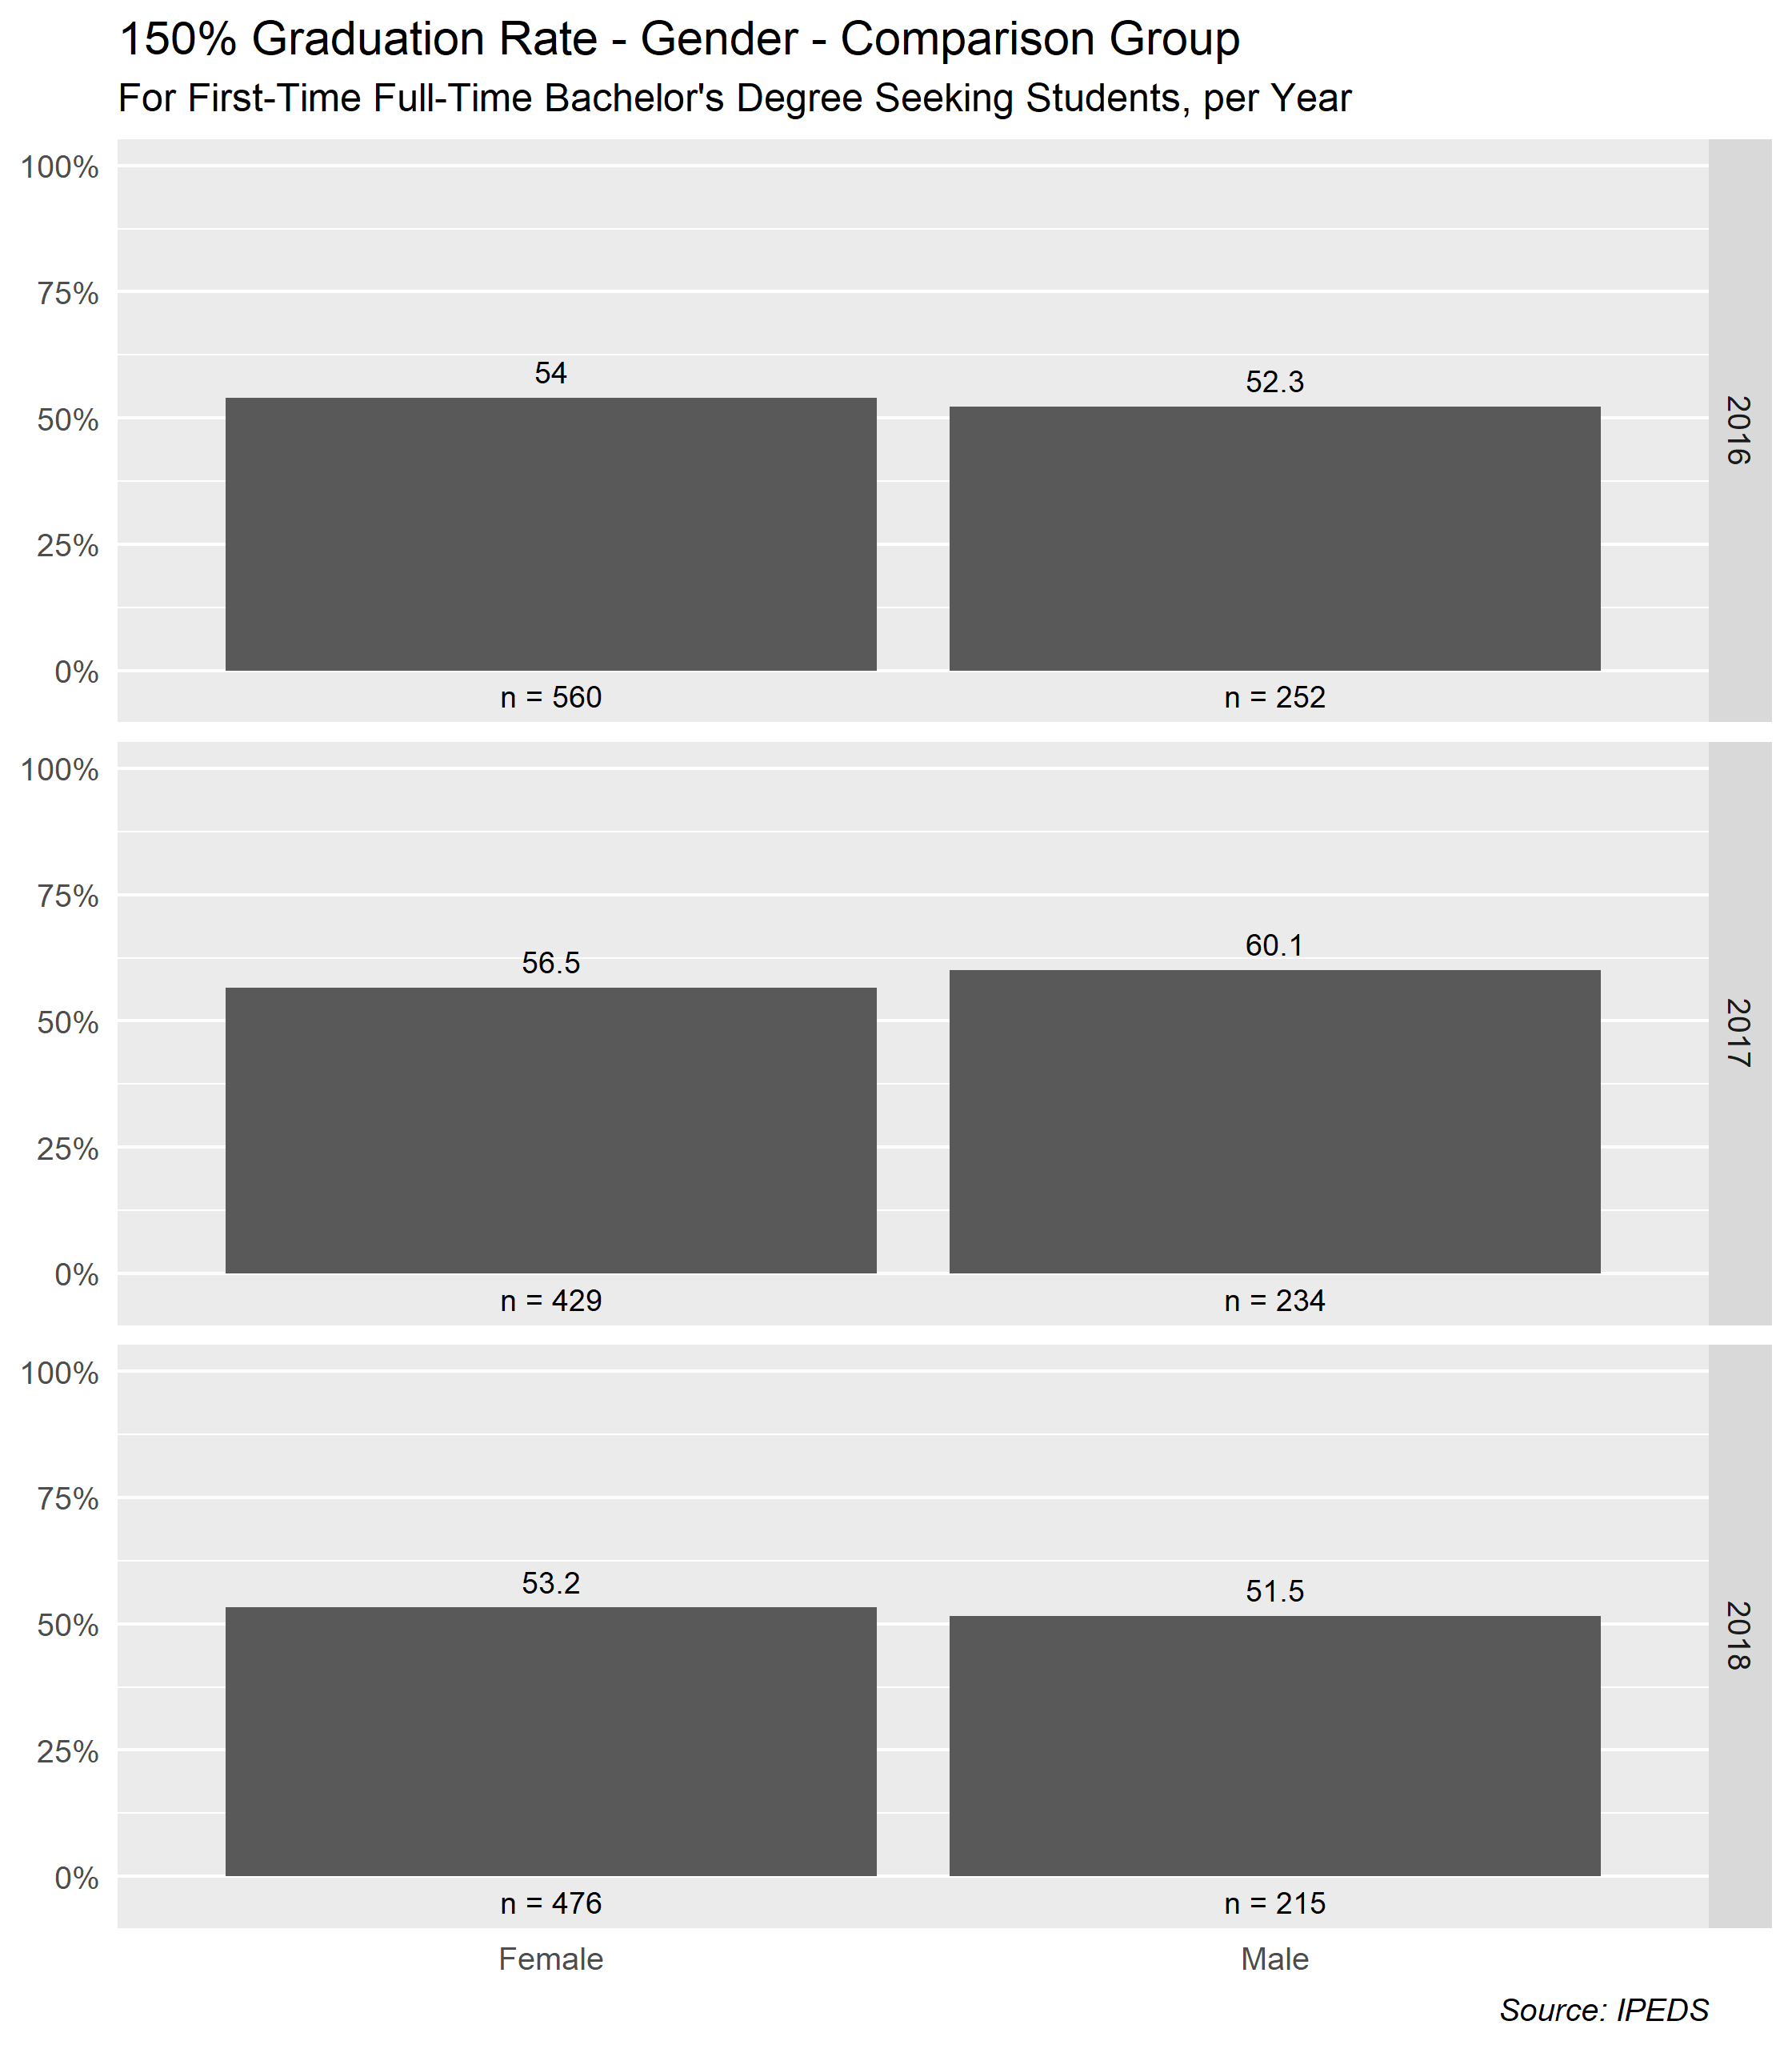  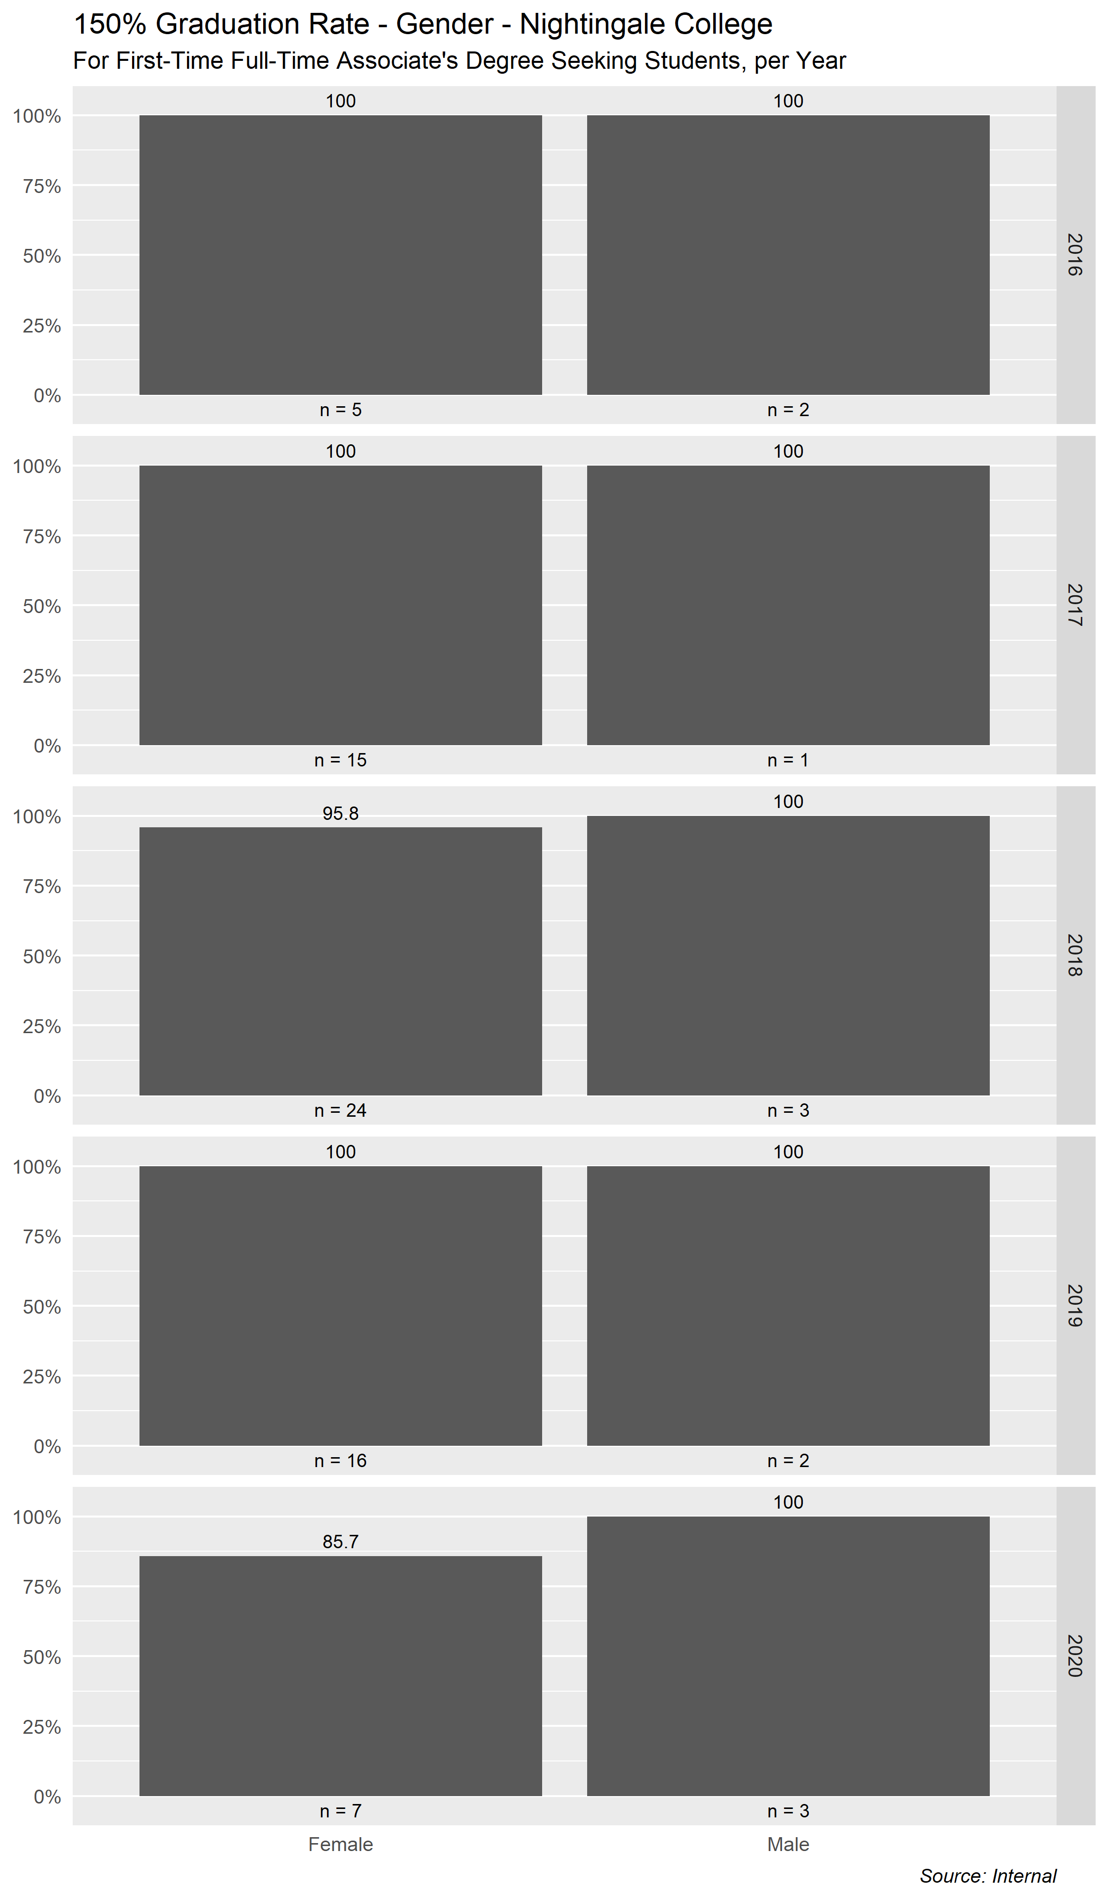  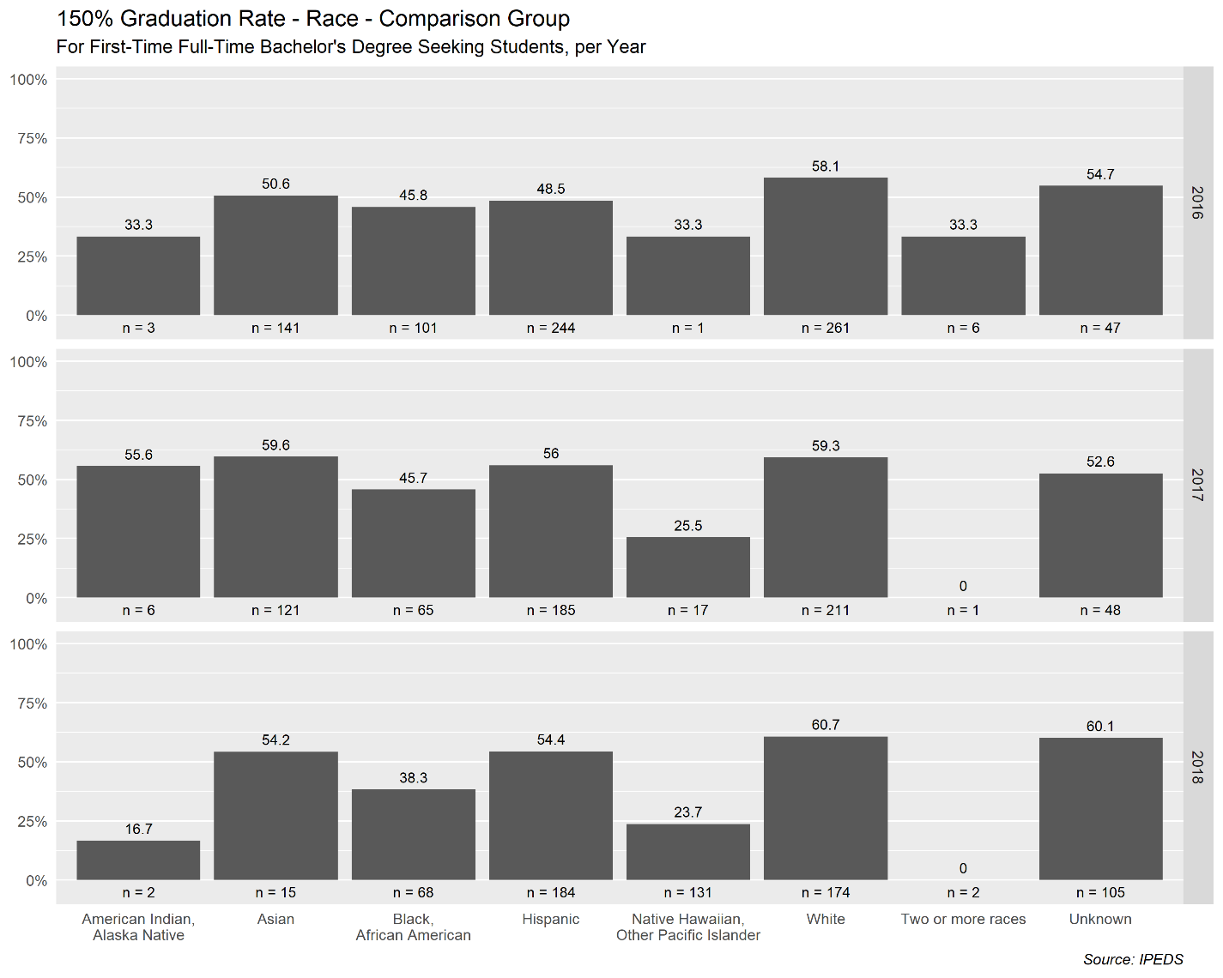  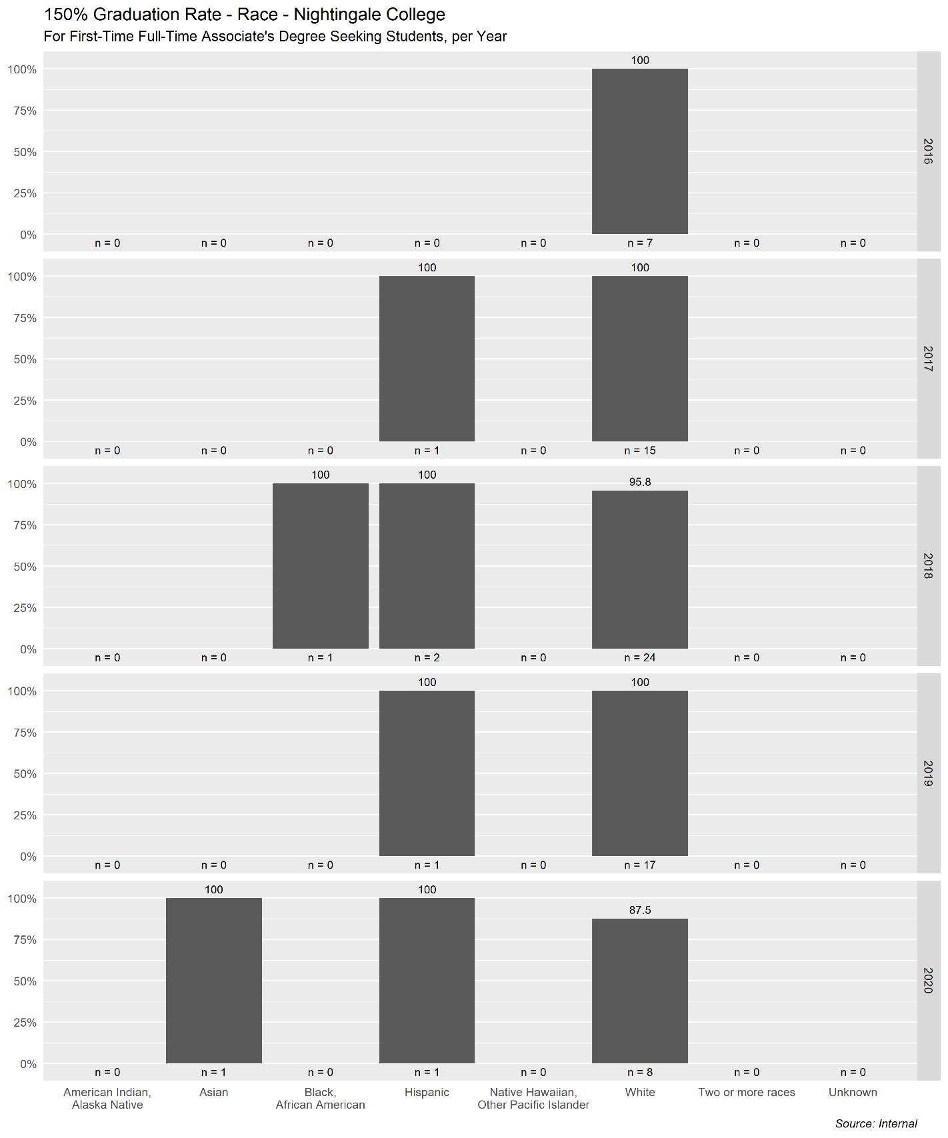
Sources | Narrative
Nexus | Our ADN Graduation Rate has been near our Overall Rate of 76% for a few years now, although our most recent starting cohort, Fall 2017, showed a small dip. Our RNBSN Graduation Rate has been consistently inconsistent for Although we do have some BSN graduates (which you will see in the Section 1.2), only learners whose 150% completion time has passed are included here.  As of August 26, 2020, of the nine (9) first-time, full-time bachelor’s degree seeking learners who began attending the Bachelor of Science in Nursing (BSN) Program in 2018, 56% are progressing toward graduating within 150% of the total program length; of the forty-eight (48) first-time, full-time bachelor’s degree seeking learners who began attending the Bachelor of Science in Nursing (BSN) Program in 2019, 90% are progressing toward graduating within 150% of the total program length; and of the sixty-four (64) first-time, full-time bachelor’s degree seeking learners who began attending the Bachelor of Science in Nursing (BSN) Program in 2020, 100% are progressing toward graduating within 150% of the total program length.
Tactical Code | Tactic
 | Driven by other metrics and tactics for retention and persistence to completion rates
NWCCU Standard | NWCCU Standard Description
1.D.2 | Consistent with its mission and in the context of and in comparison with regional and national peer institutions, the institution establishes and shares widely a set of indicators for student achievement including, but not limited to, persistence, completion, retention, and postgraduation success. Such indicators of student achievement should be disaggregated by race, ethnicity, age, gender, socioeconomic status, first generation college student, and any other institutionally meaningful categories that may help promote student achievement and close barriers to academic excellence and success (equity gaps).

1.1.2 Learner Persistence to Completion
Ownership | Last Update
Institutional Analytics and Effectiveness | 8/25/2020
Benchmark(s) | Statistics
A.D.N. - 70%  BSN- 70%  RN-to BSN- 70%  MSN - TBD | 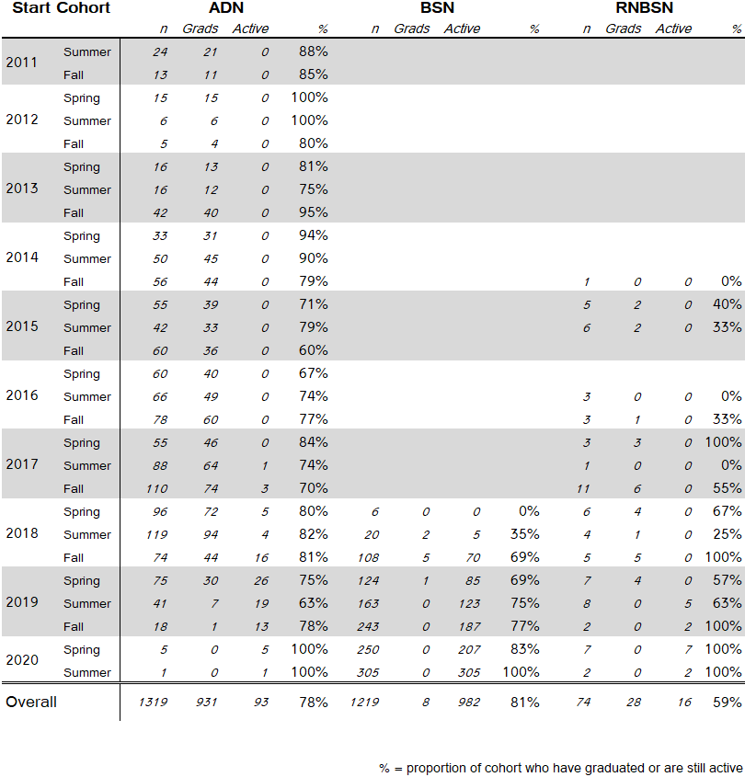  Comparisons  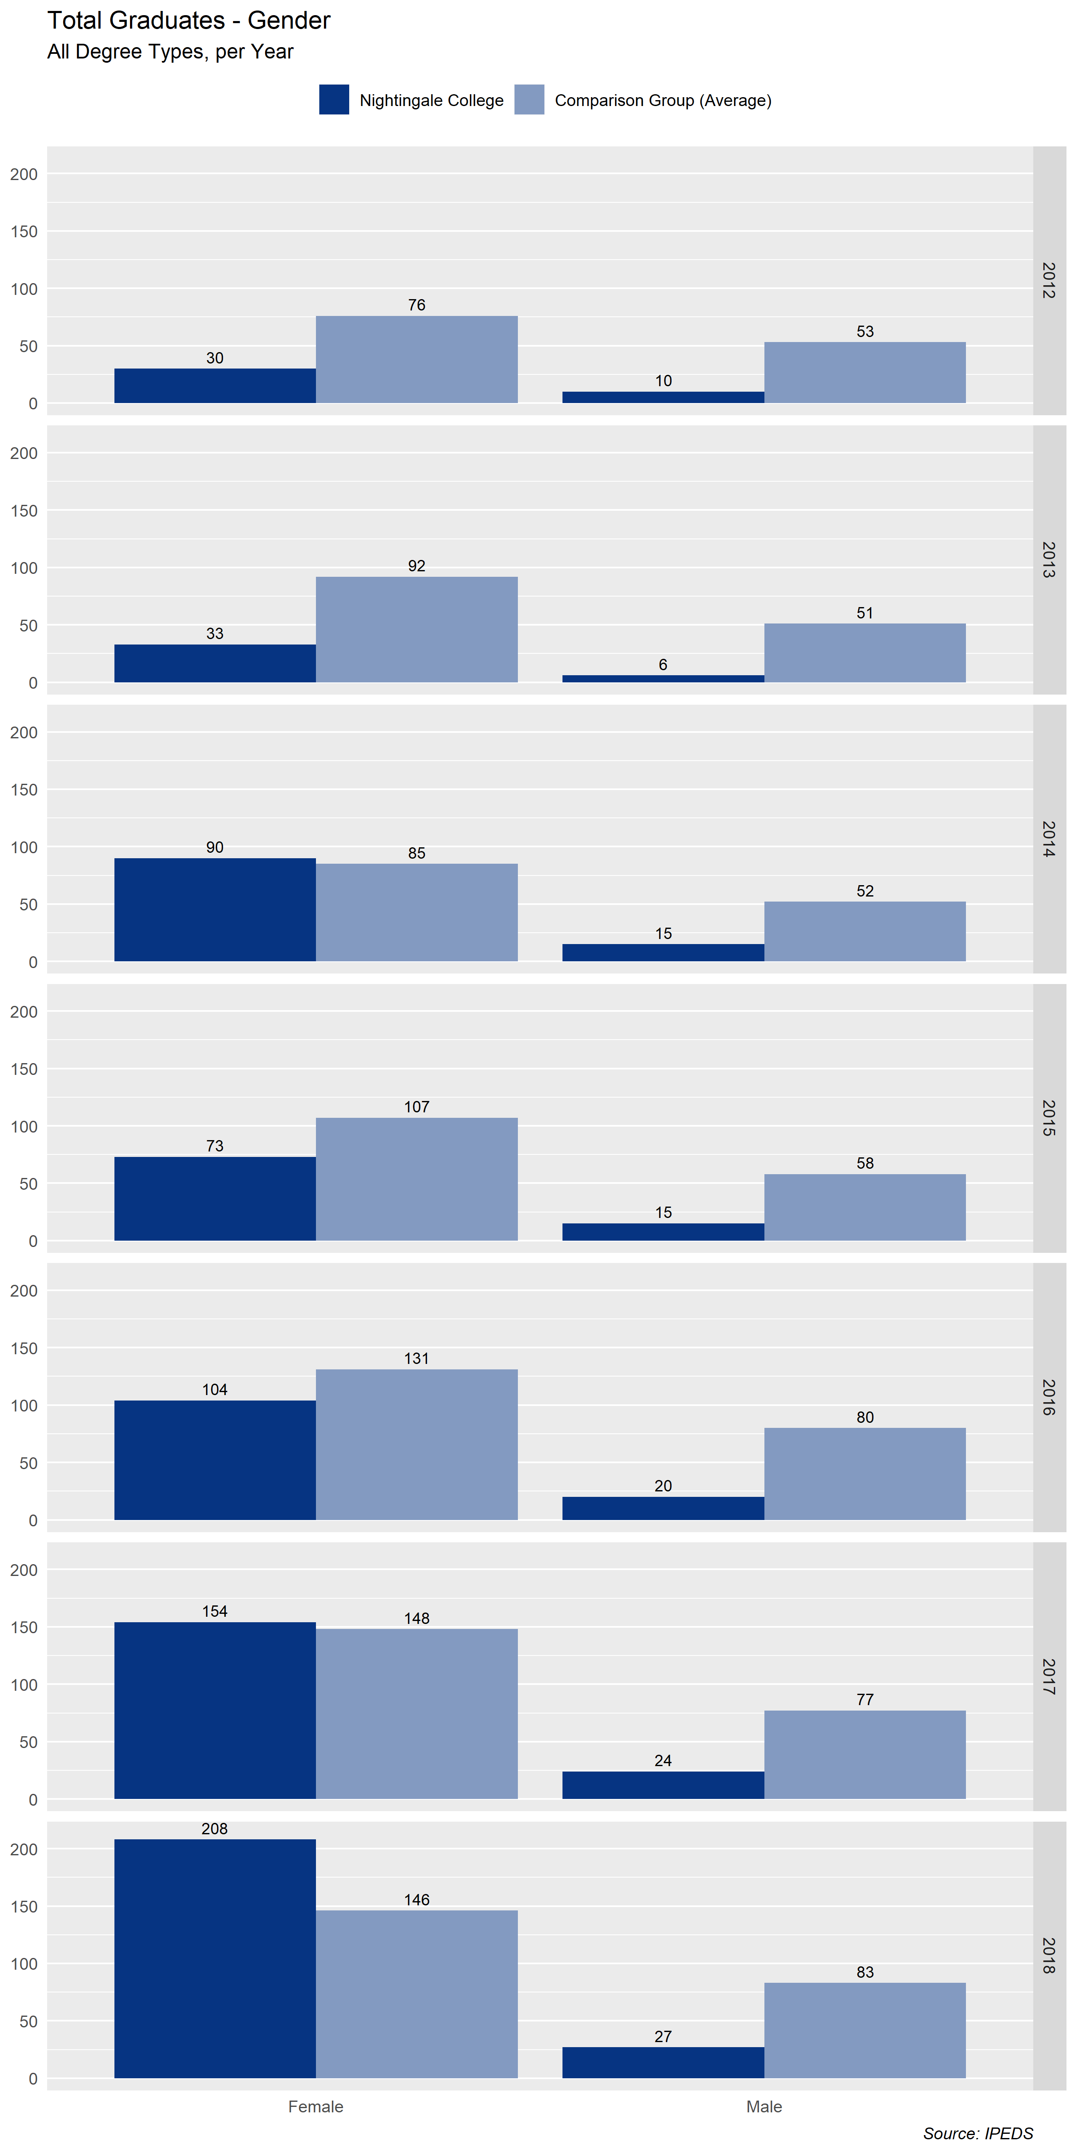  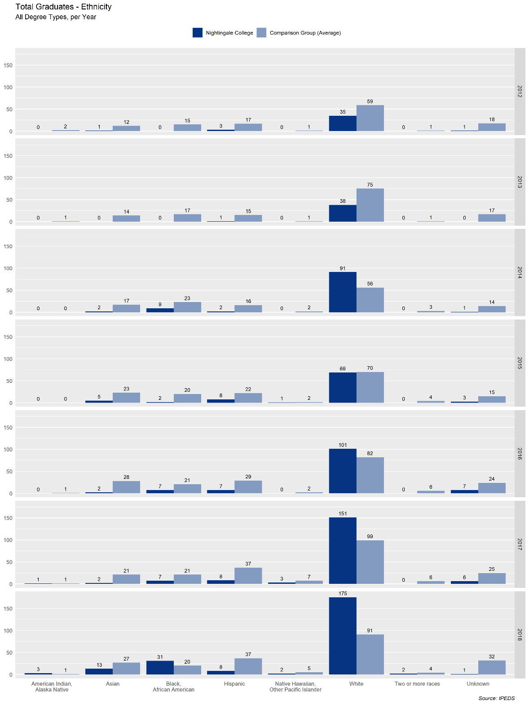
Sources | Narrative
Nexus | Our ADN Persistence Rate tracks closely with the Graduation Rate. This means that for the most part, our ADN learners are graduating on time. Our RNBSN Persistence Rate is significantly higher than the Graduation Rate. This is partly due to learners who are still Active, but also means that RNBSN learners take longer to graduate than we would expect. Our BSN Persistence Rate is almost entirely made up of Active Learners. It is hard to make any definitive judgements currently, but considering the growth of the program, the Persistence Rate seems to be favorable. As part of ongoing operations we review data weekly and determine plans for support of learners and courses. As of August 26, 2020, the first-time, full-time bachelor’s degree seeking learners in the College’s inaugural Bachelor of Science in Nursing (BSN) Program’s cohort are progressing toward graduating within 150% of the total program length as described above in Frame 1.1.1  MSN ED program commenced in Spring 2020. Therefore, there is no current baseline data.
Tactical Code | Tactic
 | Tactics connected to persistence closely tied to retention and graduation rates listed in frames 1.1.1, and 1.1.3.
NWCCU Standard | NWCCU Standard Description
1.D.2 | Consistent with its mission and in the context of and in comparison with regional and national peer institutions, the institution establishes and shares widely a set of indicators for student achievement including, but not limited to, persistence, completion, retention, and postgraduation success. Such indicators of student achievement should be disaggregated by race, ethnicity, age, gender, socioeconomic status, first generation college student, and any other institutionally meaningful categories that may help promote student achievement and close barriers to academic excellence and success (equity gaps).

1.1.3 Learner Retention
Ownership | Last Update
Institutional Analytics and Effectiveness | 8/25/2020
Benchmark(s) | Statistics
A.D.N. - 80%  BSN- 80%  RN to BSN – 80%  MSN – 80% | 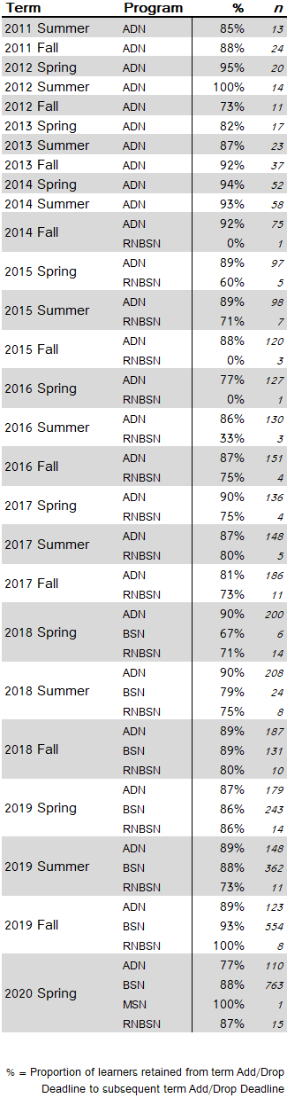  Comparisons  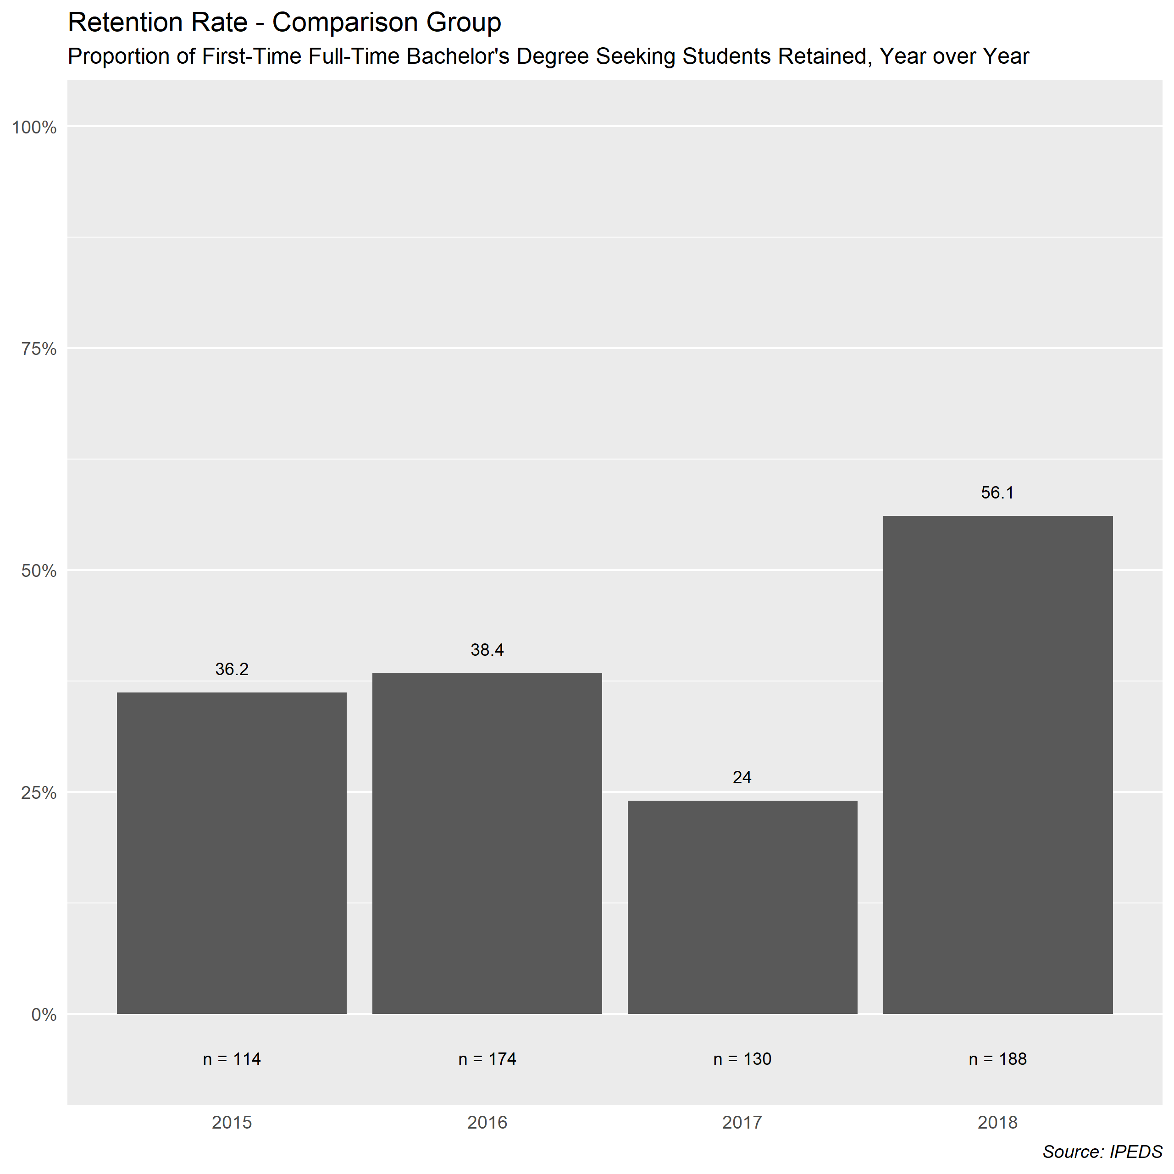  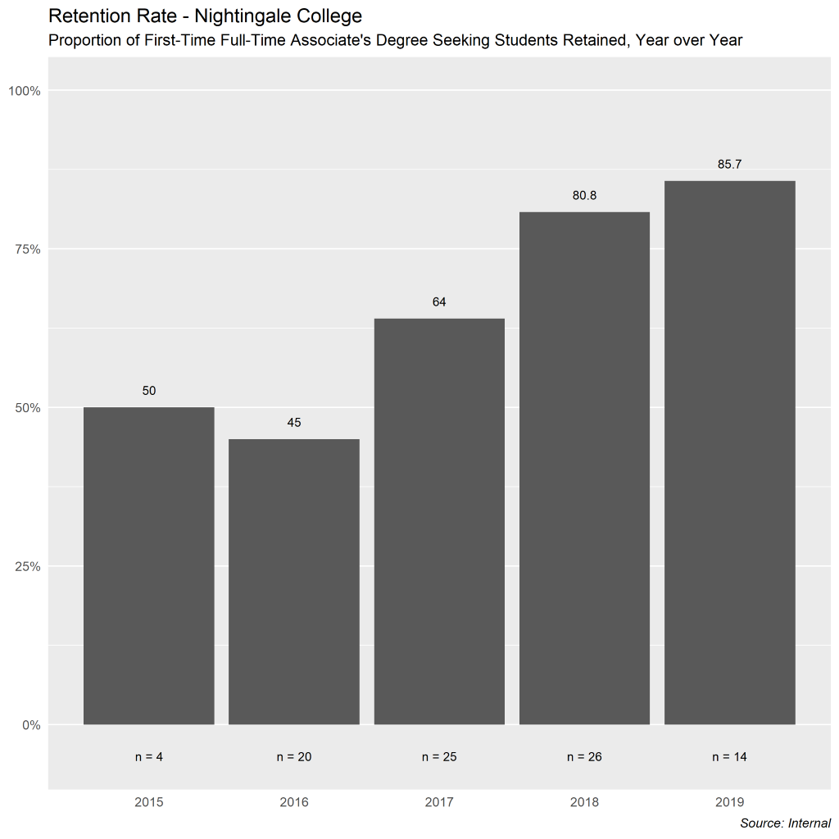
Sources | Narrative
Nexus | Table one breaks down the percentages of retention for learners overall each semester broken down by program. The benchmark for retention for all programs is set by this internal metric.  Looking at the graduation rates from table two above broken down by gender, the population continues to skew female, as the profession of nursing also skews female overall.  This third table shows the Nightingale College first-time full-time associate’s degree-seeking learners. Again, while not directly comparable to identified peers based on program type, the metrics are viewed as leading indicators toward our bachelor degree metrics. As indicated in the above table, the N size for the College has been too small to generalize on how effective the retention rates have been during overall, the numbers do show a steady increase in retention numbers year over year within the target population. As the number of ASN learners and BSN learners increases, the n size for generalization purposes will also increase.
Tactical Code | Tactic
 | Driving learner satisfaction results through retention efforts and learner support models is outlined in frame 1.1.6.
NWCCU Standard | NWCCU Standard Description
1.D.2 | Consistent with its mission and in the context of and in comparison with regional and national peer institutions, the institution establishes and shares widely a set of indicators for student achievement including, but not limited to, persistence, completion, retention, and postgraduation success. Such indicators of student achievement should be disaggregated by race, ethnicity, age, gender, socioeconomic status, first generation college student, and any other institutionally meaningful categories that may help promote student achievement and close barriers to academic excellence and success (equity gaps).

1.1.4 Learner General Education Programmatic Outcomes
Ownership | Last Update
Institutional Analytics and Effectiveness, GE | 5/15/2020
Benchmark(s) | Statistics
70% in all 8 competency frames. | 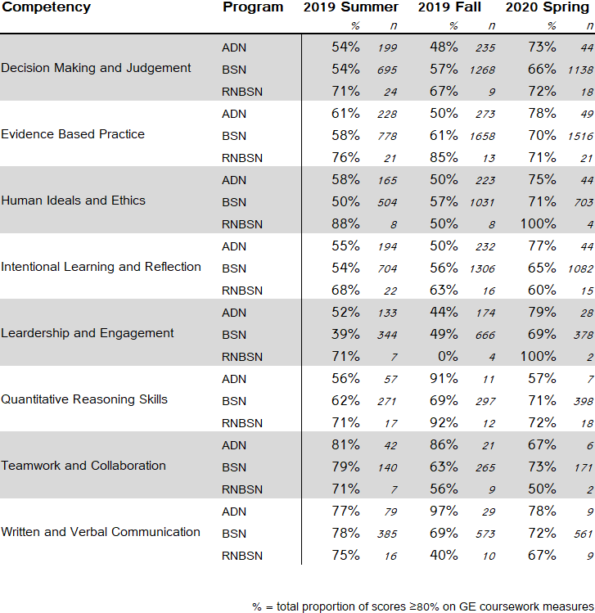
Sources | Narrative
Canvas. Tracked through the curriculum mapping documents. | For BSN – which has much larger sample sizes – we are trending up in almost every competency. ADN and RNBSN – which both have much lower sample sizes – do not show a clear trend in either direction. Initial data collection began in Summer 2019, determining refinements to the metrics. Maps available for multiple data points across multiple courses.  After curriculum review and revision prior to Summer 2020 term, new data points were identified in order to more accurately reflect measurement of the GE programmatic outcomes. This data will drive curriculum revisions as needed and will be available for review after the close of the Summer 2020 term. Programmatic Outcome measurement will be reviewed and refined as curriculum evolves in effort to keep the metrics current.  In effort to align GE Outcomes with accreditation standards, the GE team (curriculum and management) has reviewed data to suggest GE-PO8 may not accurately reflect our curriculum focus. As such, a change in GE-PO8 has been implemented effective for the Fall 2020 term. Summer data will be available and reviews in the October 2, 2020 IEP review meeting.
Tactical Code | Tactic
Implementing summer of 2020 new data points and evaluating through summer and fall 2020.
Focusing on professional development with faculty.
Implemented a thorough review process for curriculum.
NWCCU Standard | NWCCU Standard Description
1.C.6 | Consistent with its mission, the institution establishes and assesses, across all associate and bachelor level programs or within a General Education curriculum, institutional learning outcomes and/or core competencies. Examples of such learning outcomes and competencies include, but are not limited to, effective communication skills, global awareness, cultural sensitivity, scientific and quantitative reasoning, critical analysis and logical thinking, problem solving, and/or information literacy.

1.1.5 Learner Nursing Programmatic Outcomes
Ownership | Last Update
Institutional Analytics and Effectiveness, NES | 8/25/2020
Benchmark(s) | Statistics
70% in all 8 competency frames | 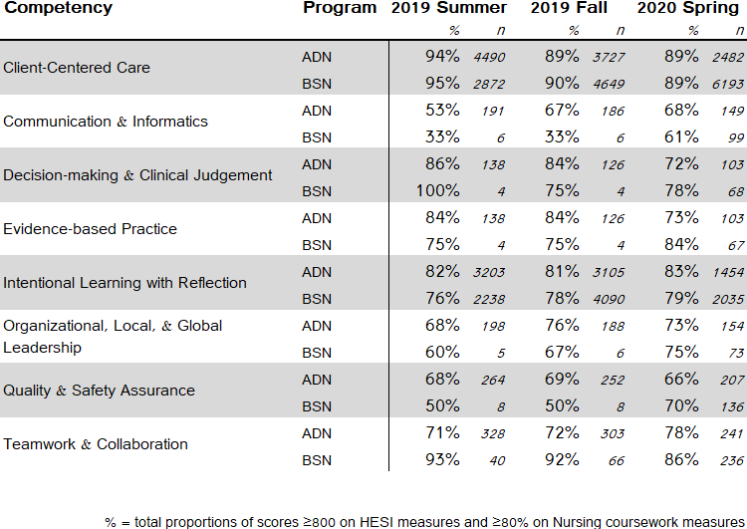
Sources | Narrative
Elsevier, Canvas, Tracked through the Curriculum mapping documents. | We are up almost across the board over the 3 semesters. We are still a bit shy of the benchmark for some of the competencies, particularly Communication & Informatics, and Quality & Safety Assurance. These competencies are receiving increased review into the data collection metrics, curriculum placement, and integration modalities to establish improvement processes.
Tactical Code | Tactic
 | Faculty development is a primary focus to ensure faculty are facilitating the curriculum in the most effective intended ways possible. Additionally, the curriculum restructure due to COVID-19 has created new opportunities to reinforce constructs, gather additional data, and improve the learning experience overall.
NWCCU Standard | NWCCU Standard Description
1.C.5 | The institution engages in an effective system of assessment to evaluate the quality of learning in its programs. The institution recognizes the central role of faculty to establish curricula, assess student learning, and improve instructional programs.

1.1.6 Learner Satisfaction
Ownership | Last Update
Institutional Analytics and Effectiveness, Learner Experience | 8/24/2020
Benchmark(s) | Statistics
4.0 as reflective of Agree on the Likert Scale. | Semester Program Score n  2019 Summer ADN 3.84 97  BSN 3.93 185  Overall 3.90 282  2019 Fall ADN 3.80 10  BSN 3.91 79  Overall 3.89 89  2020 Spring ADN 4.00 43  BSN 3.82 274  Overall 3.84 317  2020 Summer ADN 3.26 49  BSN 3.50 439  Overall 3.48 488
Sources | Narrative
Survey | As learner satisfaction has been trending near goal over the last three semesters, increased efforts have been put in place to improve systems, processes, and expressed pain-points for learners. With COVID-19 in Summer semester of 2020, learners were pulled entirely out of in person experiential learning, driving down overall satisfaction from learners wanting to be in the direct client focused care component of their educational experience. With the opening of in person experiential learning in Fall 2020, we anticipate a rebound to and potential increase from previous levels.
Tactical Code | Tactic
 | The expansion of learner support services, tutoring services, and streamlining communication channels. Learner Satisfaction is driven through all functions of the College and each function has additional metrics to improve individual functional satisfaction scores.
NWCCU Standard | NWCCU Standard Description
1.C.5 | The institution engages in an effective system of assessment to evaluate the quality of learning in its programs. The institution recognizes the central role of faculty to establish curricula, assess student learning, and improve instructional programs.

1.2.1 Alumni Licensure Overall
Ownership | Last Update
Institutional Analytics and Effectiveness, LCAS | August 20, 2020
Benchmark(s) | Statistics
Overall NCLEX Pass Rate: 80%  First-Time NCLEX Pass Rate: 70% | Overall Pass Rate  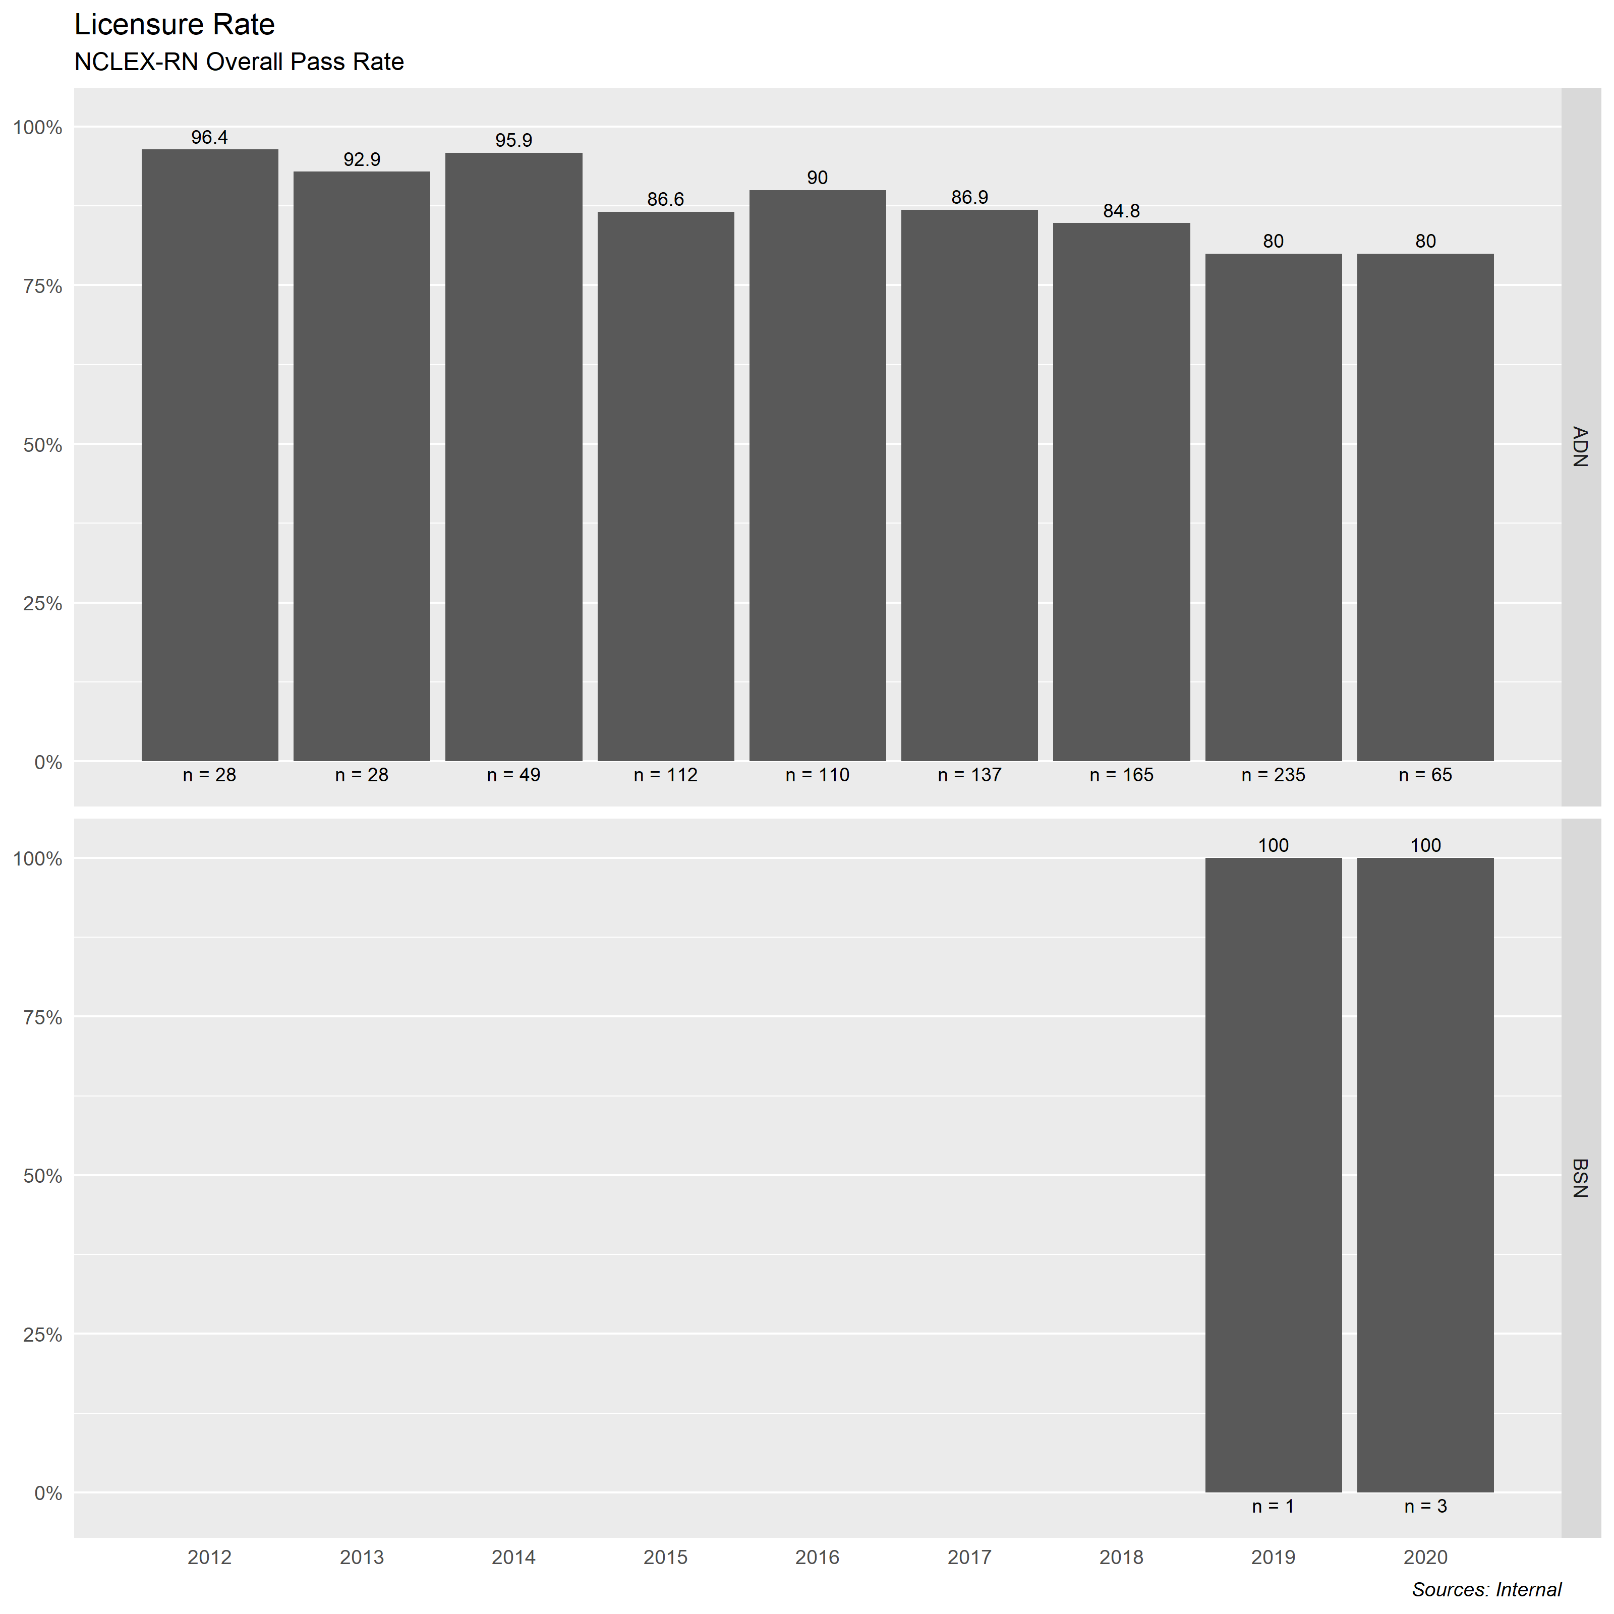  First-Time Pass Rate Comparison  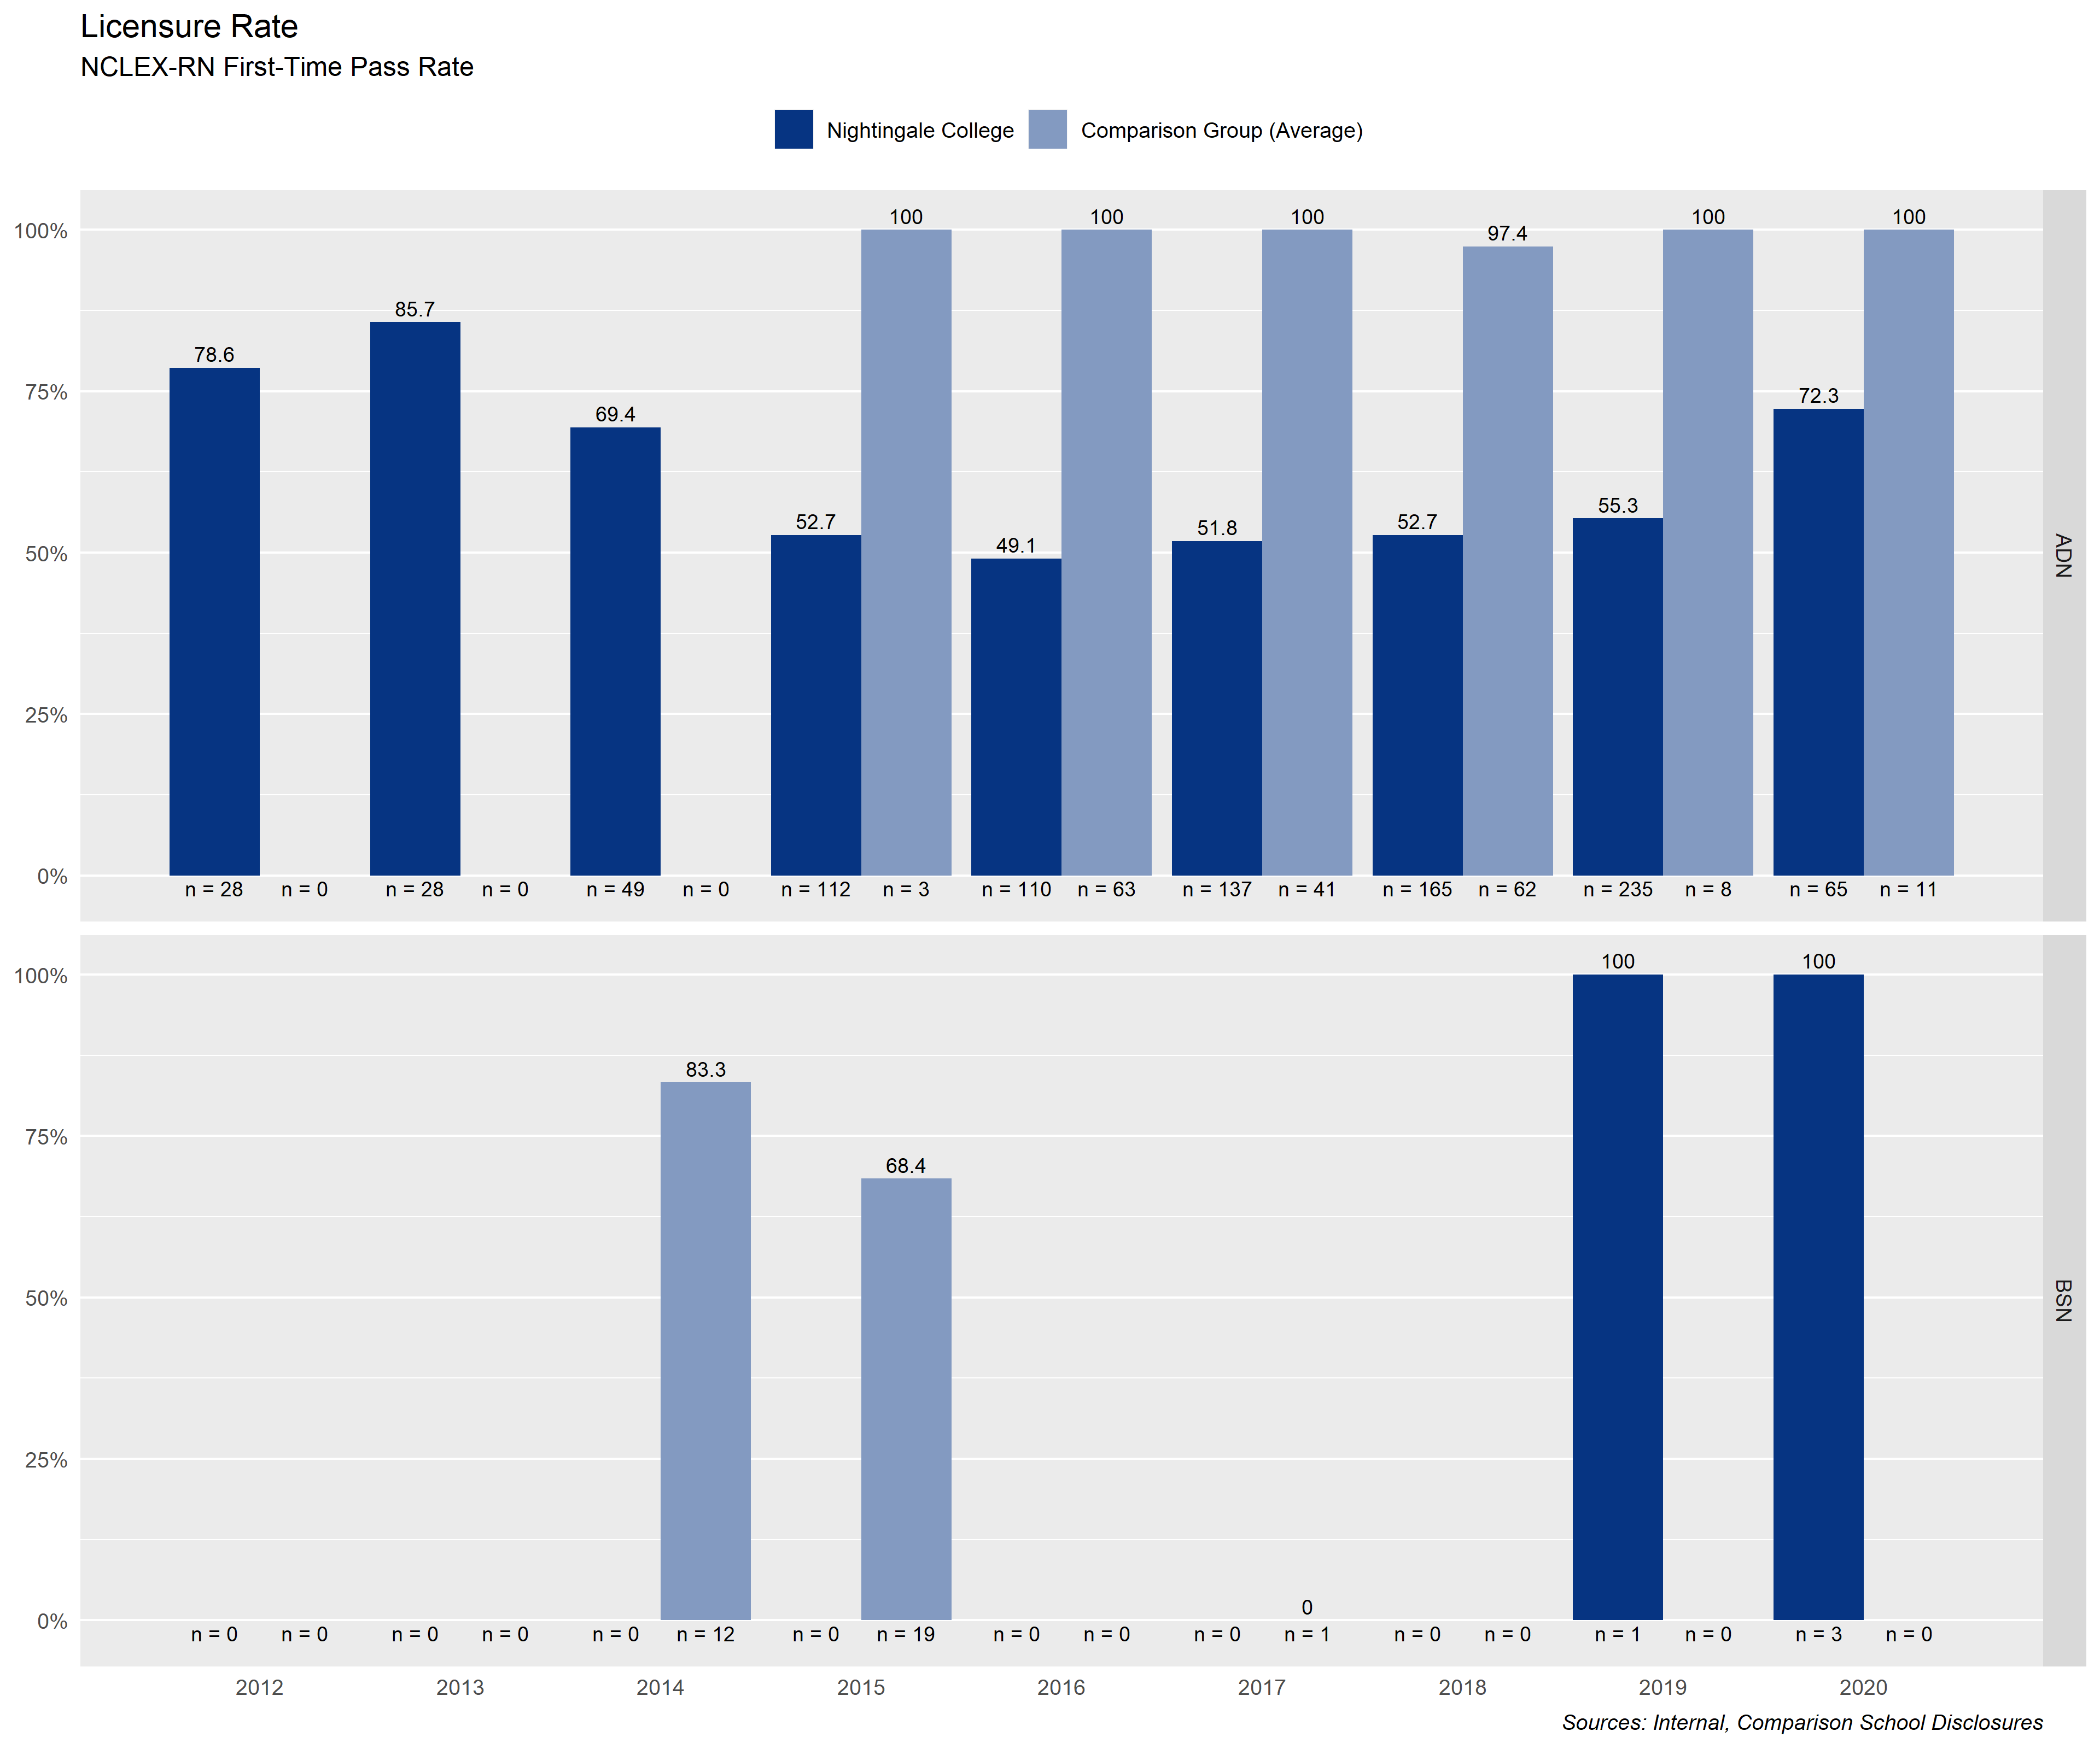
Sources | Narrative
NCLEX Master List | In progress. To align with comparable institutions and accrediting bodies, Nightingale College has established a benchmark for overall NCLEX pass rates. This number represents the number of ASN and BSN pre-licensure learners who pass the NCLEX over the total number of learners. Academic year is July 1 – June 30th, with final information posted after every member of that each graduating class from the prior year at the point of one calendar year beyond completion. As of August 26, 2020, overall pass rate for ADN learners is 85.58% and for BSN learners is 100%.
Tactical Code | Tactic
 | Using NURSYS and state boards of nursing, LCAS will track progression of prior year’s graduating classes and provide feedback to NCLEX coaches to provide additional support. Learners will be made aware of resources available through NCLEX coaches throughout their tenure, with emphasis brought just prior to completion.
NWCCU Standard | NWCCU Standard Description
1.C.1 | The institution offers programs with appropriate content and rigor that are consistent with its mission, culminates in achievement of clearly identified student learning outcomes that lead to collegiate-level degrees, certificates, or credentials and includes designators consistent with program content in recognized fields of study.

1.3.1 Collaborator Tuition Reimbursement Programs Participation
Ownership | Last Update
Collaborator Experience | 08/25/2020
Benchmark(s) | Statistics
TBD based on historical data. Currently maintaining current number of utilization. | 2017 2018 2019 2020 S1  # of Utilization 5 4 6 5  # Eligible 25 39 46 77  Total Utilization 20.00% 10.26% 13.04% 6.49%
Sources | Narrative
HRIS  Accounting | The College provides opportunities for professional growth and development by offering a tuition reimbursement benefit to all collaborators who have been employed by the College for more than one year. Providing financial contributions to faculty, staff, and administrators leads to additional degree completions post-hire, thereby elevating educational achievement during employment.  All collaborators’ educational achievements were evaluated in relationship to eligibility based on one-year tenure. The total number of collaborators who used the tuition reimbursement benefit has been divided by the total number of collaborators who would have been eligible to receive the benefit. Sample pool was based on all active collaborators for the relative year of reporting. 2020 data is accurate up to the end of semester 1.  With the implementation of the new HRIS software, these metrics will be enhanced.  Recommend combining 1.3.1 and 1.3.2 To reflect as a row in the above table.
Tactical Code | Tactic
 | Determine baseline data for participation and work to internally promote the program more aggressively.
NWCCU Standard | NWCCU Standard Description
2.F.2 | The institution provides faculty, staff, and administrators with appropriate opportunities and support for professional growth and development.

2. Personal Growth

2.3.2 Collaborator Own My Health
Ownership | Last Update
Collaborator Experience | August 25, 2020
Benchmark(s) | Statistics
Based on Q1 results, Improvement plan by Own My Health recommends a four-year improvement goal of 57% for males and 79% for females. | Annual Biometric Screening Results  Gender Total Align Elevate Lead  Male 12 1 4 7  Female 30 4 6 20  Total 42 5 10 27  11.9% 23.8% 64.3%  OMH Participation  1st Qtr 2nd Qtr  Hit Points 50 51  No Points 6 9  Partial Points 9 8  Total Enrolled 65 68
Sources | Narrative
Own My Health | Own My Health (OMH) implemented January 2020. Biometric screening results are provided annually in January. Participation in the Own My Health wellness program is reported on a quarterly basis. The College has reached 100 health insurance enrollments and will now be able to receive claims data in order to better target key health impacts and develop wellness challenges to drive improved health outcomes. Improvement data will be evaluated quarterly against the suggested benchmarks by Own My Health. Initial data is presented here, with quarter three results to be evaluated in the October 2, 2020 IEP review meeting.
Tactical Code | Tactic
3.2.3  3.2.6 | Pilot a comprehensive Wellness initiative.  Perform quarterly assessment of the wellness initiatives programs.  Redesigned challenges and points awarded, as well as further premium incentives based on initial results. Focus on making the challenges more rigorous
NWCCU Standard | NWCCU Standard Description
2.F.2 | The institution provides faculty, staff, and administrators with appropriate opportunities and support for professional growth and development.

2.2.1 Alumni Survey of Health
Ownership | Last Update
LCAS | August 6, 2020
Benchmark(s) | Statistics
Benchmark: Response to alumni survey at 10%. | Total Alumni Population Total Survey Responses as of 8/6/2020  910 36  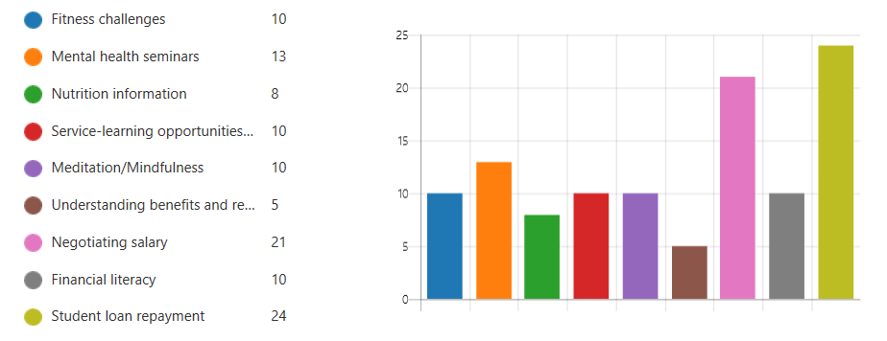
Sources | Narrative
Survey | Nightingale College has established health as a goal for alumni, to include physical, mental, emotional, and financial health. This initial survey was to determine interest in health-related topic. The next survey will seek to determine alumni perception of their own healthy behaviors and engagement with improvement.
Tactical Code | Tactic
 | A survey to collect information on learners’ holistic health and interest in interacting with Nightingale to achieve overall health has been dispatched. This will be updated as responses come in.
NWCCU Standard | NWCCU Standard Description
1.B.1 | The institution demonstrates a continuous process to assess institutional effectiveness, including student learning and achievement and support services. The institution uses an ongoing and systematic evaluation and planning process to inform and refine its effectiveness, assign resources, and improve student learning and achievement.

3. Professional Development

3.2.1 Alumni Cohort Default Rate
Ownership | Last Update
Financial Aid | 8/25/2020
Benchmark(s) | Statistics
Below 10% per annum | 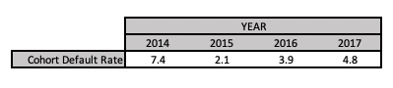
Sources | Narrative
Audit Reports | The College engages with a third party to manage minimizing the College’s cohort default rate (CDR), who performs targeted outreach efforts to reduce the overall CDR. The College uses Ascendium Education Solutions Administration’s product called Cohort Catalyst (CC). Their role is to reach out to all the College graduates and withdrawals using NSLDS reports. Traditionally, CC attempts a contact to grads/withdrawn learners at the time they leave school and before their payments begin.  The college has also partnered with Piecewise, a company that conduct the exit counseling with learners who are leaving the College. This exit counseling provides all the requirements from the Department of Education plus information such as who is the learners loan servicer, contact information, and when payments will begin. Piecewise receives data of the graduating cohort and withdrawn learners from the master list the College provides.  The College monitors the CDR annually, using the data provided to assess those who are listed on the report. Items that are reviewed are withdrawals listed versus the number of grads listed. Historically, most individuals in default on the CDR report are in the withdrawn status. The College data is researched and compared to the CDR report for accuracy. If errors are discovered the appeal process is begun to resolve discrepancies.  An assessment of the increase in the CDR percentage has revealed that student body has increased every year resulting in a larger population of graduates and withdrawn learners. Although an increase is reflected in the last three years of CDR reports, The College is well below the proscribed minimum by the Department of Ed.
Tactical Code | Tactic
NWCCU Standard | NWCCU Standard Description
2.G.5 | Students receiving financial assistance are informed of any repayment obligations. The institution regularly monitors its student loan programs and publicizes the institution’s loan default rate on its website.

3.2.2 Alumni Upward Career Mobility
Ownership | Last Update
LCAS | August 6, 2020
Benchmark(s) | Statistics
Participation: 10% in survey  Percentage of positive job increase: 50%  Metrics set based on a minimum level of participation in inaugural survey. | Total Alumni population Total survey responses 8/6/20 Total indicating upward mobility Percentage of self report  910 36 21 58%
Sources | Narrative
Survey | Nightingale College has a vested interest in the career mobility of alumni and seeks feedback from prior learners to determine how their education and relationship has impacted their career opportunities.  As of August 6, 2020, there have been 36 responses to the alumni survey. N=910. Of those, 21 report having earned a promotion in their careers since completing their studies with Nightingale College; 58%.
Tactical Code | Tactic
 | A survey to collect information on alumni career progression is written and was dispatched May 14, 2020 with a reminder on July 1, 2020; deadline of July 31st. Continual refinement to drive participation. Survey to be dispatched as graduates reach one year from completion.
NWCCU Standard | NWCCU Standard Description
1.D.2 | Consistent with its mission and in the context of and in comparison with regional and national peer institutions, the institution establishes and shares widely a set of indicators for student achievement including, but not limited to, persistence, completion, retention, and postgraduation success. Such indicators of student achievement should be disaggregated by race, ethnicity, age, gender, socioeconomic status, first generation college student, and any other institutionally meaningful categories that may help promote student achievement and close barriers to academic excellence and success (equity gaps).

3.2.3 Alumni Professional Associations
Ownership | Last Update
LCAS | August 6, 2020
Benchmark(s) | Statistics
Benchmark: Response to alumni survey at 10%. | Total Alumni Population Total Survey Responses as of 8/6/2020 Participating in Professional Associations Percentage of Respondents Reporting Participation in Professional Associations  910 36 18 50%
Sources | Narrative
Survey | In an effort to maintain a professional relationship with alumni, Nightingale College seeks to understand the interest in participating in professional associations as well as the types of associations sought by alumni. This will assist in the College developing relationships with those associations to better facilitate alumni participation.  Nightingale College has a vested interest in maintaining connection with learners beyond the point of separation. To that end, Nightingale College seeks to understand alumni interest level in participating in an honors society and, if sufficient interest exists, to charter a membership with alumni chapters to best serve alumni and maintain connection with the college.  As of August 6, 2020, there have been 36 responses to the alumni survey. N=910. Of those responses, 18 (50%) indicated that they are involved in professional associations. The organizations include American Nurses Association, Nevada Nurses Association, AAAMA, CAUTI/CLABSI Committee, ACCN, AANAC, AACN, AORN, UHMS, WOC, and Wyoming Nurses Association.  As of August 6, 2020, 36 responses to the Alumni Survey with 3.06/5.0 as the average for alumni interest in participating in an alumni honor society. N=910.
Tactical Code | Tactic
 | Nightingale College will increase participation in alumni surveys by establishing relationships with learners prior to the point of completion. Additionally, the College will strive to inform learners and alumni about professional associations and the benefits of participating.
NWCCU Standard | NWCCU Standard Description
1.D.2 | Consistent with its mission and in the context of and in comparison with regional and national peer institutions, the institution establishes and shares widely a set of indicators for student achievement including, but not limited to, persistence, completion, retention, and postgraduation success. Such indicators of student achievement should be disaggregated by race, ethnicity, age, gender, socioeconomic status, first generation college student, and any other institutionally meaningful categories that may help promote student achievement and close barriers to academic excellence and success (equity gaps).

4. Serve Diverse Communities

4.1 Learner Demographics
Ownership | Last Update
Institutional Analytics and Effectiveness | 7/21/2020
Benchmark(s) | Statistics
No benchmark set. Currently evaluating the population set against communities we serve to evaluate how reflective we are of the populations. | Comparisons  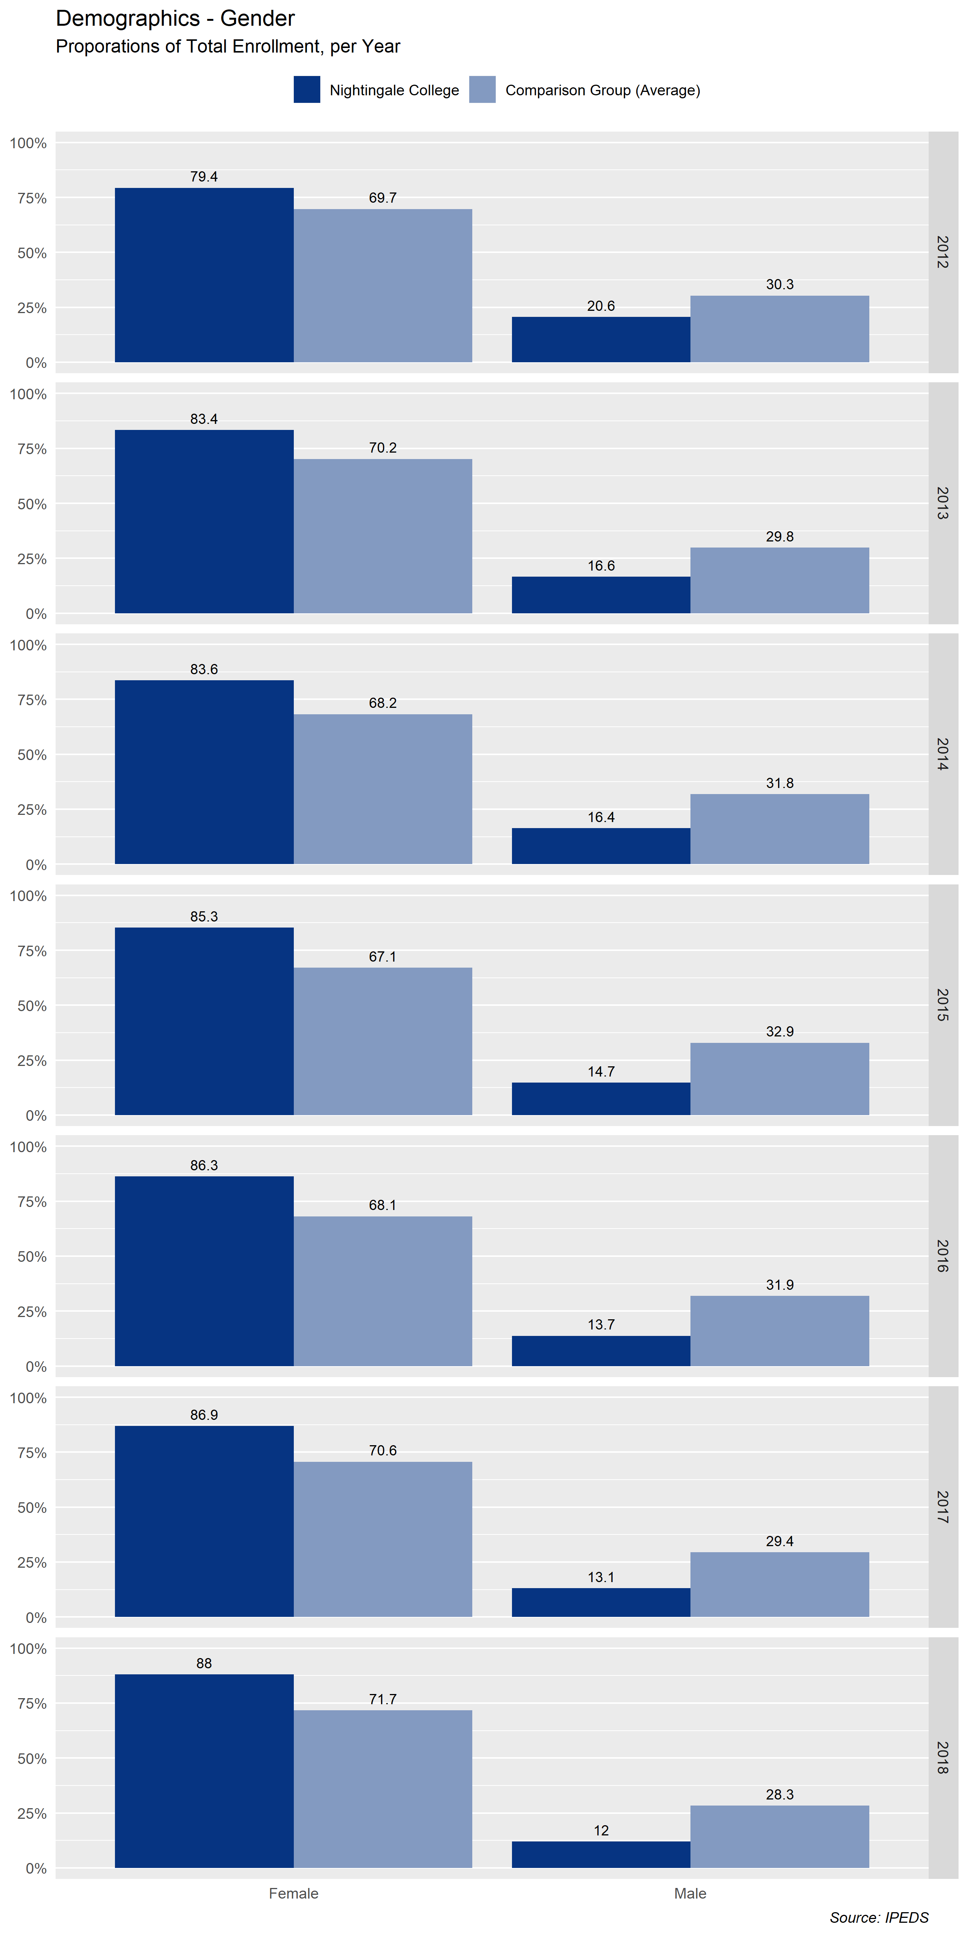  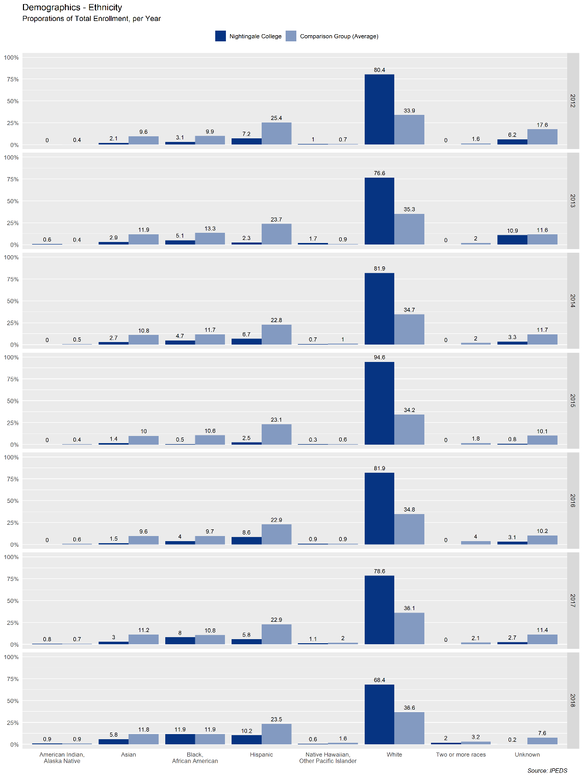
Sources | Narrative
IPEDS | Table 1 above compares total enrollment numbers by gender to the comparable institutions’ data. The population totals for female-identified learners come close to balancing with comparable institutions, while the population of male-identified learners continues to lag as of 2018. This is due, in part, to the diversity of program offerings at the comparable peer institutions versus the single-purpose offerings of the College.  Table 2 above compares the total enrollment based on ethnicity to the comparable institutions’ average. While showing a predominate white population back in the years tracking up to 2018, much of the enrollment was focused in the intermountain west and rural communities, which carries a predominately white population. The College’s population set shows a more diverse population than the demographics of the states we served at those times, and trending along the populations of comparable institutions.
Tactical Code | Tactic
 | To drive forward the diversity of the nursing profession in setting and population.
NWCCU Standard | NWCCU Standard Description
1.D.2 | Consistent with its mission and in the context of and in comparison with regional and national peer institutions, the institution establishes and shares widely a set of indicators for student achievement including, but not limited to, persistence, completion, retention, and postgraduation success. Such indicators of student achievement should be disaggregated by race, ethnicity, age, gender, socioeconomic status, first generation college student, and any other institutionally meaningful categories that may help promote student achievement and close barriers to academic excellence and success (equity gaps).

4.2 Alumni Work Placement Settings
Ownership | Last Update
LCAS | August 6, 2020
Benchmark(s) | Statistics
Accreditation standard is 70% | ASN RN-BSN BSN  2018-2019 76.30% 100%  These will be updated at least monthly until all graduates from each cohort have been graduated for one calendar year beyond the point of the final conferral date.  The data are collected and reported 6 months after the close of the academic year (June 30th) annually. 2019-2020 data will be reported on January 1, 2021.
Sources | Narrative
Survey | The Learner, Career, and Alumni Services department is tasked with tracking alumni to determine whether their work is directly related to their degree and in which type of setting they are employed. LCAS also assists with resume and cover letter preparation as well as interviewing skills.  LCAS establishes relationships with learners before the point of separation to encourage them to communicate with the College after graduation and licensure and report where they are working. LCAS also reaches out to learners who do not reach back voluntarily. The College also utilizes Equifax to track learners who do not respond to requests for information.
Tactical Code | Tactic
 | These will be updated at least monthly until all graduates from each cohort have been graduated for one calendar year beyond the point of the final conferral date.
NWCCU Standard | NWCCU Standard Description
 | No directly applicable standard.

4.3 Collaborator Demographics
Ownership | Last Update
Collaborator Experience | 08/25/2020
Benchmark(s) | Statistics
No specific benchmark set, but it is being tracked to ensure we are inclusive of a larger collaborator pool. | 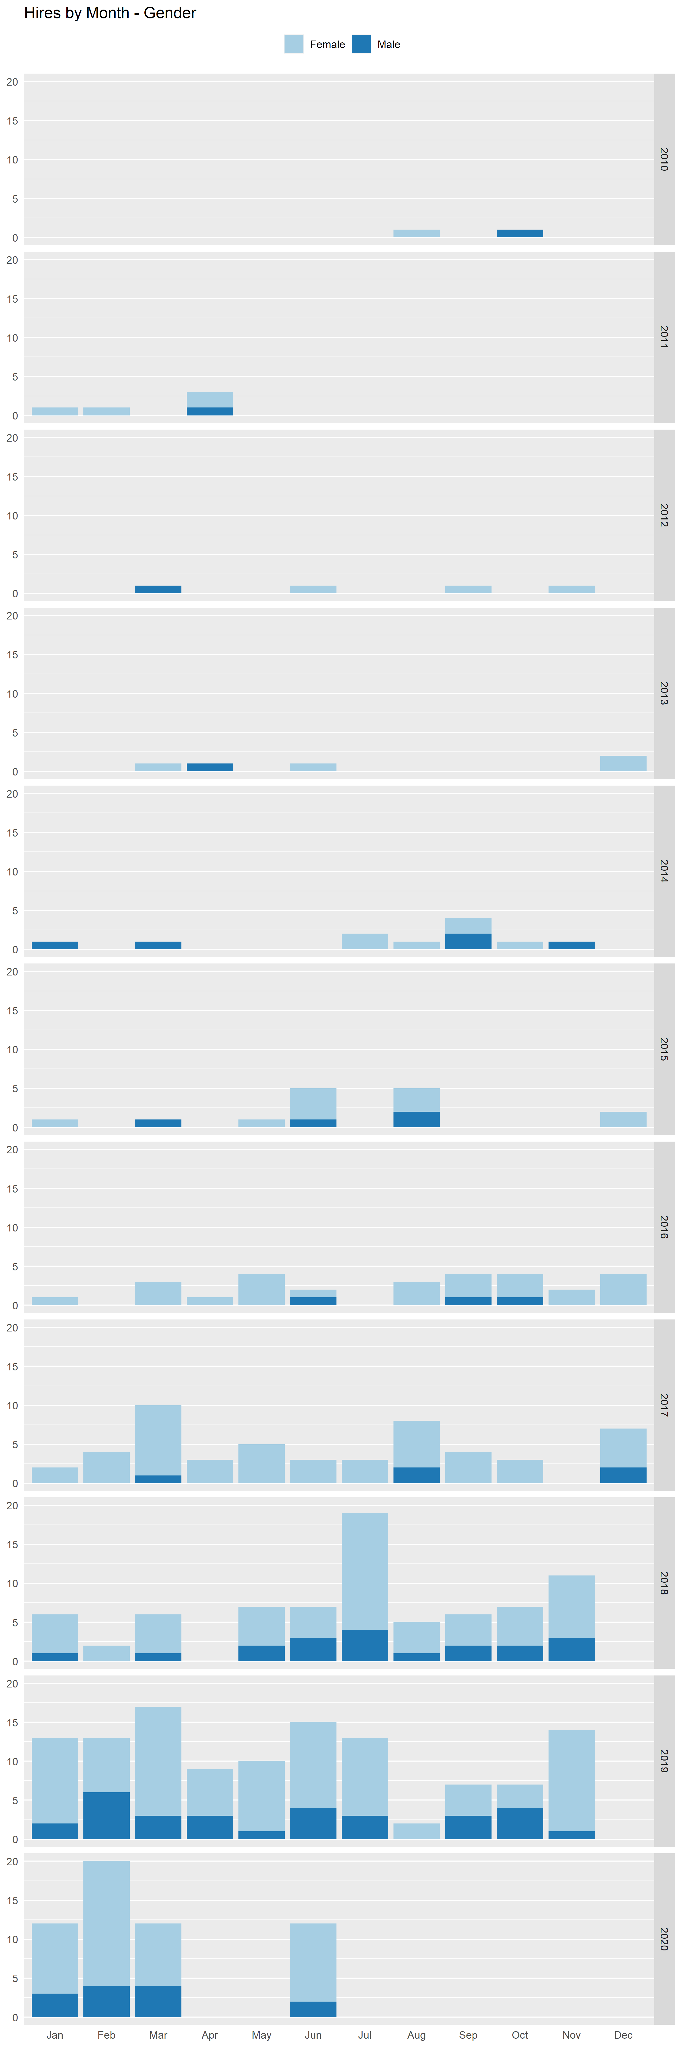  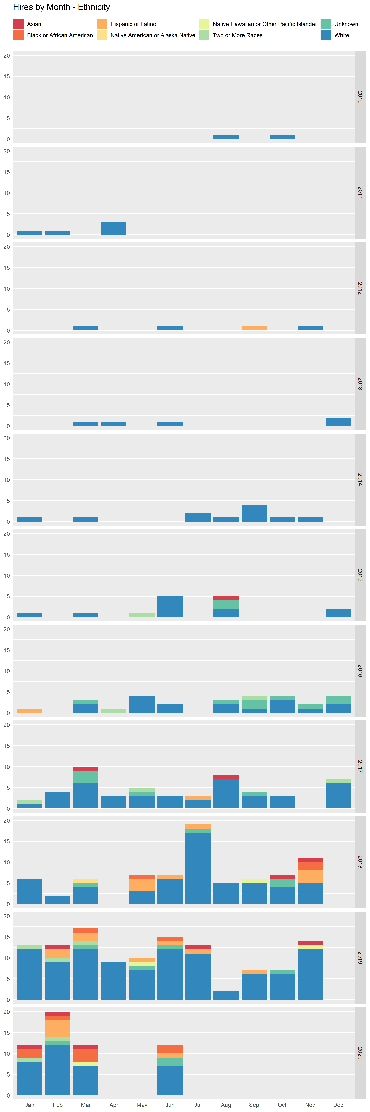  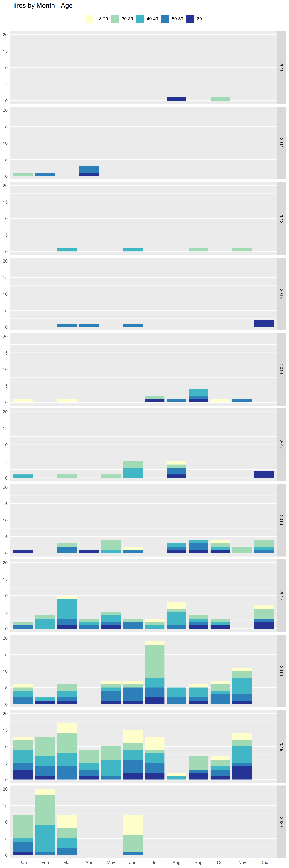
Sources | Narrative
Employee Files | Tables above are broken down by age, gender, and ethnicity by year. Following the year over year growth and change demonstrates a wider diversification of the collaborator population. These metrics also reflect a wider population of collaborators hired beyond the intermountain west where the population reflects a wider diversity in general. While these numbers have no specific metric for targeting specific diverse population sets, the tracking here allows us to ensure a lower rate of homogeneity as we continue to scale for growth. These tables reflect that awareness to ensure increased diversification of our collaborator population sets.
Tactical Code | Tactic
 | The College will continue to seek opportunities to diversify its workforce and create an inclusive environment for all collaborators.
NWCCU Standard | NWCCU Standard Description
2.F.3 | Consistent with its mission, programs, and services, the institution employs faculty, staff, and administrators sufficient in role, number, and qualifications to achieve its organizational responsibilities, educational objectives, establish and oversee academic policies, and ensure the integrity and continuity of its academic programs.

4.5 Advisory Boards and Committees
Ownership | Last Update
Curriculum | 8/25/2020
Benchmark(s) | Statistics
Representatives and partnerships from nursing education, industry stakeholders, specialty organizations, current learners and alumni which represent diverse Communities of Interest (race, ethnicities, cultures, multiple education program levels), | Current 2020 Advisory Board Membership Groups  Internal members External Members Alumni Learners  10 18 4 4  *Setting benchmarks based on representation of our diverse environments.
Sources | Narrative
Advisory Board Minutes | Distance Learning and Nursing experts from academia and industry, provide guidance for curriculum; advise in program and course development efforts; advise of new programs for development; and contribute to the development of program competencies to be in line with the demands of today’s employers. To ensure the most effective programs and current informational delivery, a diverse cross section is necessary for the advisory board. The table above shows the current composition of the board listed by the group they help to represent on that board. We regularly review the board composition and consider new perspectives to provide the broad-based perspectives imperative to our continued success. These categories represent a cross section of these various groups as outlined in the benchmark. Full committee/ board membership is available at any time upon request.
Tactical Code | Tactic
 | To ensure a cross section of voices from communities of interest, locations, settings, and stakeholders we are looking to do more direct outreach to additional communities, partners, and nursing professional interest groups.
NWCCU Standard | NWCCU Standard Description
1.B.3 | The institution provides evidence that its planning process is inclusive and offers opportunities for comment by appropriate constituencies, allocates necessary resources, and leads to improvement of institutional effectiveness.

5. Viability and Sustainability

5.1 Financial Viability, Cash, and Operating Capital
Ownership | Last Update
Finance | 8/25/2020
Benchmark(s) | Statistics
Positive net income, Composite Score 1.5 or above, positive cash flow, 90/10 below 85% | 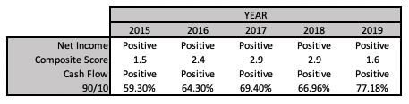
Sources | Narrative
External audit reports, internal financial reports | The Finance function monitors the financial viability, cash, and operating capital on a monthly basis and reports monthly to the Board of Managers. This includes budget to actuals, re-forecasted financials where needed, cash projections, and changes to the financial model based on the most relevant data.  Year over year trends and comparisons of financial metrics are routinely reviewed along with metrics required by the College’s accrediting bodies and the Department of Education.
Tactical Code | Tactic
 | Operationalized.
NWCCU Standard | NWCCU Standard Description
2.E.1 | The institution utilizes relevant audit processes and regular reporting to demonstrate financial stability, including sufficient cash flow and reserves to achieve and fulfill its mission.

5.2 Revenue Scale and Population
Ownership | Last Update
Finance | 8/25/2020
Benchmark(s) | Statistics
Cash flow positive covering projected growth and current operations. | 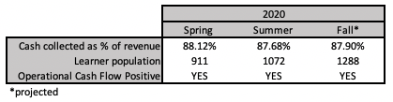  See also statistics in sections 5.1 and 6.2
Sources | Narrative
Financial forecast and budget | The Finance function monitors the financial viability, cash, and operating capital on a monthly, semester, and yearly basis and reports monthly to the Board of Managers.  The Finance department uses the budget to actuals, re-forecasted financials, cash projections, and changes to the financial model based on the most relevant data, to create a financial forecast to manage the growth of the College’s revenue and population in a sustainable way.
Tactical Code | Tactic
 | Currently operationalized.
NWCCU Standard | NWCCU Standard Description
2.E.1 | The institution utilizes relevant audit processes and regular reporting to demonstrate financial stability, including sufficient cash flow and reserves to achieve and fulfill its mission.

6. Risk Assessment Include internal and external audits.

6.1 External Audits
Ownership | Last Update
Finance | 8/25/2020
Benchmark(s) | Statistics
Unqualified opinions. No material adjustments, no material weaknesses. Title IV question costs below 0.1%. No repeat Findings. | 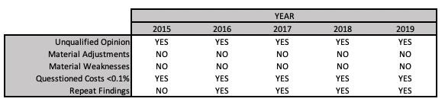
Sources | Narrative
Financial Audits | The College engages an external auditor on a yearly basis. The College’s independent board has both a finance and audit committee that reviews the external audit, and corresponding recommendations from the independent third-party audit firm.
Tactical Code | Tactic
 | To bring all external audit findings to the benchmark.
NWCCU Standard | NWCCU Standard Description
2.E.1 | The institution utilizes relevant audit processes and regular reporting to demonstrate financial stability, including sufficient cash flow and reserves to achieve and fulfill its mission.

6.2 Internal Audits
Ownership | Last Update
Finance | 8/25/2020
Benchmark(s) | Statistics
Positive net income, Composite Score 1.5 or above, positive cash flow, 90/10 below 85%, Budget to Actual variations within $5,000 and 5% of budget. | 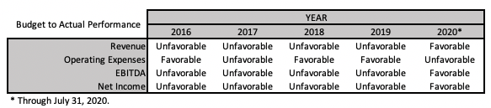  See also statistics in section 5.1 above
Sources | Narrative
Internal Reporting | The College routinely reviews the financial data for accuracy on a monthly, quarterly, and yearly basis. These reviews include a review by the controller and CFO of the balance sheet, income statement, cash flow, comparisons to the approved budget. These internal audits and reviews are used to assess the effectiveness and accuracy of the processes and procedures around financial reporting and are adjusted based on these findings.
Tactical Code | Tactic
 | To bring all frames into favorable status.
NWCCU Standard | NWCCU Standard Description
2.E.1 | The institution utilizes relevant audit processes and regular reporting to demonstrate financial stability, including sufficient cash flow and reserves to achieve and fulfill its mission.

7. IEP Items in Development

1.2.2 Alumni Additional Certifications
Ownership | Last Update
LCAS | August 26, 2020
Benchmark(s) | Statistics
Benchmark: Response to alumni survey at 10%. | Total Alumni Population Total Survey Responses as of 8/6/2020 Total Licensed in at Least One State Total Licensed in Two or More States  910 36 36 10  No additional certifications, only additional state licensures are reported.
Sources | Narrative
Survey | Nightingale College seeks to engage with alumni to determine additional training that may be needed or desired to open additional training opportunities. The survey was initially written and deployed in June 2020.
Tactical Code | Tactic
 | The survey will be deployed in June of each year to graduates from the prior year. Initiatives to drive greater participation in voluntary surveys will be included in tactical planning this Fall for 2021.
NWCCU Standard | NWCCU Standard Description
1.D.2 | Consistent with its mission and in the context of and in comparison with regional and national peer institutions, the institution establishes and shares widely a set of indicators for student achievement including, but not limited to, persistence, completion, retention, and postgraduation success. Such indicators of student achievement should be disaggregated by race, ethnicity, age, gender, socioeconomic status, first generation college student, and any other institutionally meaningful categories that may help promote student achievement and close barriers to academic excellence and success (equity gaps).

1.2.3 Alumni Further Degree Seeking
Ownership | Last Update
LCAS | July 24, 2020
Benchmark(s) | Statistics
Benchmark to be set at October 2020 meeting | In development. Will look at stackable credentials and degree completions from ASN through BSN levels.
Sources | Narrative
National Clearinghouse | Nightingale College is working to develop an alumni community to better track the placement and educational pursuits of graduates. A proposal for alumni involvement has been presented to the Leadership Council for approval. Additionally, Nightingale College has added a Master of Science in Nursing degree in addition to the Bachelor of Science in Nursing to facilitate advanced education. The proposal includes an Alumni Survey to collect information about graduate who have pursued advanced degrees at other institutions. This metric will be measured only to BSN completion. Data will be compiled and reported from the National Clearinghouse by September 15, 2020.
Tactical Code | Tactic
 | Coordinating with National Clearinghouse to get clean metric data.
NWCCU Standard | NWCCU Standard Description
1.D.2 | Consistent with its mission and in the context of and in comparison with regional and national peer institutions, the institution establishes and shares widely a set of indicators for student achievement including, but not limited to, persistence, completion, retention, and postgraduation success. Such indicators of student achievement should be disaggregated by race, ethnicity, age, gender, socioeconomic status, first generation college student, and any other institutionally meaningful categories that may help promote student achievement and close barriers to academic excellence and success (equity gaps).

1.3.2 Collaborator Degree Completion Post-Hire
Ownership | Last Update
Collaborator Experience | 08/25/2020
Benchmark(s) | Statistics
TBD based on historical data tables. | New reporting item for IEP.
Sources | Narrative
Collaborator Files | Metrics being compiled for IEP semester review meeting to be held October 2, 2020.
Tactical Code | Tactic
 | To drive further degree completion among collaborators.
NWCCU Standard | NWCCU Standard Description
2.F.2 | The institution provides faculty, staff, and administrators with appropriate opportunities and support for professional growth and development.

2.3.1 Collaborator Elevation Survey
Ownership | Last Update
Collaborator Experience | 08/25/2020
Benchmark(s) | Statistics
TBD based on survey baseline | Metrics being compiled. New reporting item.
Sources | Narrative
Survey | Initial survey developed in summer 2020, implementation for September 2020 with initial results to be included in the October 2, 2020 IEP review meeting.
Tactical Code | Tactic
 | Ensure we provide resources necessary for collaborators to continue their personal elevation.
NWCCU Standard | NWCCU Standard Description
2.F.2 | The institution provides faculty, staff, and administrators with appropriate opportunities and support for professional growth and development.

2.1.1 Learner Survey of Health
Ownership | Last Update
LCAS | May 29, 2020
Benchmark(s) | Statistics
Benchmark: Response to Learner survey at 30%. | New Item – in development with results expected be included in October 2020 report.
Sources | Narrative
Survey | A survey to collect information on students’ holistic health is written and expected to be dispatched during August New Learner Orientation. The survey will be deployed annually in March to compare data collected from new learners with progress made through the academic tenure.
Tactical Code | Tactic
 | A survey to collect information on learners’ holistic health has been dispatched. This will be updated as responses come in.
NWCCU Standard | NWCCU Standard Description
1.B.1 | The institution demonstrates a continuous process to assess institutional effectiveness, including student learning and achievement and support services. The institution uses an ongoing and systematic evaluation and planning process to inform and refine its effectiveness, assign resources, and improve student learning and achievement.

3.1.1 Learner Nursing Associations Memberships
Ownership | Last Update
LCAS | July 24, 2020
Benchmark(s) | Statistics
Benchmark: Response to Learner survey at 30%. Benchmark to report participation will be set based on survey response. | To be discussed in the IEP review on October 2, 2020, Survey to be deployed August 31, 2020.
Sources | Narrative
Survey | In development. Benchmark to be established through NLO surveys deployed in August 2020.  Nightingale College cares about the needs and expectations of learners. To this end, we will ask learners what credentials/certifications they currently hold and what they believe they will need to be successful as a nurse.
Tactical Code | Tactic
 | Survey will be dispatched during August 2020 New Learner Orientation to establish a baseline and interest level in earning credentials and certifications beyond the degrees and nursing licenses that are currently part of the Nightingale curriculum. After a year of evaluation, strategies will be developed to include or not include additional certifications beyond current offerings.
NWCCU Standard | NWCCU Standard Description
1.D.2 | Consistent with its mission and in the context of and in comparison with regional and national peer institutions, the institution establishes and shares widely a set of indicators for student achievement including, but not limited to, persistence, completion, retention, and postgraduation success. Such indicators of student achievement should be disaggregated by race, ethnicity, age, gender, socioeconomic status, first generation college student, and any other institutionally meaningful categories that may help promote student achievement and close barriers to academic excellence and success (equity gaps).

3.3.1 Collaborator Professional Development / CEUs / Conference Attendance
Ownership | Last Update
Collaborator Experience | 08/25/2020
Benchmark(s) | Statistics
Benchmarks to be set based on historic data in October review. | Collaborator CEU Hours  2017 2018 2019 2020 S1 2020 S2 2020 S3  80 178.85 389 114
Sources | Narrative
Collaborator Files | Continuing education units is available for active faculty from 2017 through the end of the first semester of 2020.
Tactical Code | Tactic
 | Promote and support collaborators in attaining CEUs and professional development.
NWCCU Standard | NWCCU Standard Description
2.F.2 | The institution provides faculty, staff, and administrators with appropriate opportunities and support for professional growth and development.

3.3.2 Collaborator Additional Certifications
Ownership | Last Update
Collaborator Experience | 08/25/2020
Benchmark(s) | Statistics
Benchmarks to be set based on historic data. | New reporting item for IEP.
Sources | Narrative
Collaborator Files | Metrics being compiled for IEP semester review meeting to be held October 2, 2020.
Tactical Code | Tactic
NWCCU Standard | NWCCU Standard Description
2.F.2 | The institution provides faculty, staff, and administrators with appropriate opportunities and support for professional growth and development.

4.4 Number of Healthcare Partners and Setting Type
Ownership | Last Update
Partnerships, IAE | 8/26/2020
Benchmark(s) | Statistics
TBD by October IEP Review | Available by October IEP Review
Sources | Narrative
DDC Scorecard | Learner hours per setting type is a new metric we are working to develop. Partnerships is working on a complete list of partners by setting type. IAE will be collating the partner setting types with historical learner scheduling. The statistics will be available by the October IEP Review, and a benchmark will be set.
Tactical Code | Tactic
 | Create an area scorecard to ensure settings diversity.
NWCCU Standard | NWCCU Standard Description
2.I.1 | Consistent with its mission, the institution creates and maintains physical facilities that are accessible, safe, secure, and sufficient in quantity and quality to ensure healthful learning and working environments that support and sustain the institution’s mission, academic programs, and services.

